**eWALL Intelligent Services**



**This document presents the intelligent services implemented in eWALL that can be used by the eWALL Open Source Community. The document belongs to eWALL consortium and any use of the document requires the reference to eWALL Open Source (http://gitghub.com/ewallprojecteu)**

# Table of contents

Table of contents 2

1 Lifestyle Reasoners 4

1.1 Vital Signs Lifestyle Reasoner 4

1.1.1 Background 4

1.1.2 Implementation 5

1.1.3 Reasoner output 10

1.1.4 References 12

1.2 Daily Physical Activity Lifestyle Reasoner 13

1.2.1 Background 13

1.2.2 Implementation 17

1.2.3 Reasoner output 21

1.2.4 References 21

1.3 Mood Lifestyle Reasoner 23

1.3.1 Background 23

1.3.2 Implementation 24

1.3.3 Reasoner output 28

1.3.4 References 28

1.4 Sleep Lifestyle Reasoner 28

1.4.1 Background 28

1.4.2 Implementation 35

1.4.3 Reasoner output 41

1.4.4 References 44

1.5 Daily Functioning Lifestyle Reasoner 45

1.5.1 Background 45

1.5.2 Implementation 46

1.5.3 Reasoner output 48

1.5.4 References 49

1.6 Home Environment Lifestyle Reasoner 49

1.6.1 Background 49

1.6.2 Implementation 51

1.6.3 Reasoner output 52

1.6.4 References 53

1.7 Calendar Lifestyle Reasoner 55

1.7.1 Background 55

1.7.2 Implementation Scenarios 56

1.7.3 References 57

1.8 eWALL Interaction Lifestyle Reasoner 57

1.8.1 Background 58

1.8.2 Implementation 59

1.8.3 Reasoner output 65

1.8.4 References 68

2 Wellbeing Advertisement Reasoner 68

2.1 Background 68

2.2 Implementation 69

2.2.1 Main Screen Implementation 69

2.2.2 Reasoner Implementation 70

3 Automatic Goal-Setting 76

3.1 Background 76

3.2 Implementation 78

3.3 References 81

Bibliography 82

# 

# Lifestyle Reasoners

Lifestyle Reasoners within eWALL are components that process and store long term data that follows certain patterns or routines that define the lifestyle of the user. The aim of these components is to predict behavior and to detect (slow or fast) changes that might indicate a change in the user‘s health status. To do so, the lifestyle reasoners consume medium level data (e.g. processed data from service bricks) from multiple sources and derive semantically meaningful patterns. The data is processed, stored, and compared with medium- and long-term data stored in the cloud and the reasoner determines e.g. whether a variation falls within the expected thresholds, or employs more complex methods to determine deviation. These results can then be exposed through an API for use in other applications or other processing components. The output of a reasoner can also be an input for a combined lifestyle reasoner. The main distinction between lifestyle reasoners and the Intelligent Decision Support System (IDSS) is that the reasoners presented in this deliverable make decisions about the short-, medium-, or long-term past, whereas the IDSS reasoners reason about the *now*.

Given this distinction between IDSS components and Lifestyle Reasoners, the lifestyle reasoners are for the most part ―passive‖ components in the eWALL cloud, in that they tend not to initiate immediate engagement with the user. The only exception to this is the Vital Signs Lifestyle Reasoner (see Section 4) where a detection of a deviation of a lifestyle pattern could be considered so important that the reasoner itself sends notifications to the primary user and/or caregivers. In general though, the reasoning over long term does not neccesitate alerting and as such the components are designed and set up as information sources. A common, and more appropriate scenario to notifications on lifestyle data would be, for example, that the IDSS component ―Virtual Coach‖ request the physical activity lifestyle pattern of the Daily Physical Activity Lifestyle Reasoner (see Section 5) and decides to initiate a conversation with the user (whenever he is available and up for it) to discuss his slowly declining levels of physical activity.

## Vital Signs Lifestyle Reasoner

### Background

The Vital Signs (VS) Lifestyle Reasoner (LR) gathers information about the primary user’s vital signs with respect to their *heart rate*, *blood pressure*, *heart rate variability* and *oxygen saturation*. Based on the collected data, the reasoner analyses and tracks the medical condition of the primary user. The focus of the reasoner is to monitor the primary user’s health status and to identify possible changes that develop in the user’s health such as occurrence of hypertension, atrial tachycardia, decreased heart rate variability, etc. Timely diagnosis and treatment of the above mentioned health issues are of outmost importance for the primary users **(ACSQHC, 2009),** **(APTA, 2016)**, **(Griffiths et al., 2015)**, **(Boulanger & Toghill, 2009)**, **(Gonik & Rudolph, 2011)**, especially for the case of Chronic Obstructive Pulmonary Disease (COPD) patients **(Jensen et al., 2013)**, **(Aidar, 2009)**, **(Handa et al., 2012)**, **(Cameron et al., 2012)**, and **(Lellouche et al., 2013)**.

The Lifestyle Reasoner takes into account the following inputs:

* *Heart rate (HR)* **(Jensen et al., 2013)**
* *Systolic blood pressure (SBP)* **(Aidar, 2009)**
* *Diastolic blood pressure (DBP)* **(Aidar, 2009)**
* *Heart rate variability (HRV)* **(Handa et al., 2012)**
* *Oxygen saturation (OS)* **(Cameron et al., 2012)**

It should be noted for the input data mentioned above that there are currently no existing devices in the eWALL setup that can provide Heart Rate Variability information. However, the reasoner has been developed and is capable of processing heart rate variability data, if the data is provided in a possible future extension of the platform.

Based on the input data described above, the Lifestyle Reasoner provides the following output / results:

* *Data vectors*, with respect to the input parameters in the reasoner. The data vectors can be formatted for different temporal dimensions like per hours in a day, per days in a week, per weeks in a month and per months in a year.
* *Statistical mean* with respect to the user’s heart rate, blood pressure, heart rate variability, blood pressure and oxygen saturation. The statistical mean is calculated as a floating average.
* Vital signs (health status) deviation detection and notification:
  + - Detection/notification of tachycardia occurrence based on the heart rate measurements. Comment: Tachycardia can be used as an initial warning to indicate worsened coronary health of the user.
    - Detection/notification of hypertension based on blood pressure measurements. Comment: Hypertension can be used as an initial warning to indicate worsened coronary health of the user.
    - Detection/notification of decreased HRV values based on HRV measurements. Comment: Decreased HRV can be used as an initial warning to indicate worsened coronary health of the user.
    - Detection/notification of decreased OS values based on OS measurements. Comment: Decreased OS can be used as an initial warning to indicate worsened coronary health of the user. Users with decreased OS should avoid any physical exercise.

The data from the reasoner can be used to provide short-term and long-term overviews of the user’s vital signs status in the *caregiver application* by sending notifications and alarms – these alarms represent notifications that are managed by the eWALL system with highest priority – related to the user’s vital signs stadium **(Crossley et al., 2011)**. The vital signs reasoner also uses notifications and alarms to inform the user regarding his vital signs via the user’s *main screen* **(Crossley et al., 2011)**.

### Implementation

The implementation of the vital signs lifestyle reasoner was performed during the fourth development cycle (“Cycle 4”) that started in November 2015. It targets collection of information regarding the primary user’s vital signs with respect to the reasoned inputs mentioned above. It also enables the reasoner to analyse and track the medical condition of the primary user based on the collected data.

#### Monitored parameters

Table 1 provides information about the parameters monitored by the vital signs lifestyle reasoner, as well as the time periods over which these values are averaged and monitored.

Table 1: Vital signs monitored parameters and averaging intervals.

|  |  |  |  |  |  |
| --- | --- | --- | --- | --- | --- |
| **Parameter** | **Daily** | **Weekly** | **Monthly** | **Yearly** | **Floating** |
| Heart rate | YES | YES | YES | YES | YES |
| Heart rate variability | YES | YES | YES | YES | YES |
| Systolic blood pressure | YES | YES | YES | YES | YES |
| Diastolic blood pressure | YES | YES | YES | YES | YES |
| Oxygen saturation | YES | YES | YES | YES | YES |

The reasoner is also capable of detecting obvious outliers and excludes them from the averaging process. Additionally, the reasoner can provide a *floating* average. The floating average computes the average value of a given vital sign, based on all available measurement samples. More precisely, the reasoner can compute the average value of the given user’s vital sign parameter from the initial start of using the eWALL system until the last available measurement. The reasoner discards all values for the floating average that are obvious outliers in the system (e.g. samples that are gathered while the user is exercising, or values that represent errors in the sensing device).

The *daily*, *weekly*, *monthly* and *yearly* averages can be used to detect a decline or incline in the parameters during specific time periods of interest (i.e. *continuous* deviation detection). The floating average can be used to detect *significant* deviations of the parameters with respect to the average values (i.e. *instant* deviation detection).

#### Deviation detection

The main focus of the vital signs lifestyle reasoner is to detect negative (deteriorative) deviation in the monitored parameters. The detected deviation can be either:

* Continuous deviation. The continuous deviation can be either represented as a slight or long-term (chronic) incline or decline of the vital signs parameters. *For example: A tachycardia present for a period of several days will be treated as a slight deviation, while a tachycardia present for a period of several years will be treated as a chronic deviation.* Here it should be noted that due to the limited time available, the implementation of detection algorithms for long-term (chronic) deviations cannot be measured in the timespan of the eWALL evaluation trials, so are implemented primarily for a sake of completeness.
* Instant deviation. The instant deviation represents a case where the vital signs parameters experience a significant instant incline or decline from the average value of the vital signs parameter. *For example: if the current measured value of the heart rate is significantly higher than the average value, the event will be treated as an instant deviation.*

Table 2 and Table 3 summarize the continuous and instant deviation detection scenarios.

Table 2: Continuous deviation.

|  |  |
| --- | --- |
| **Parameter** | **Deviation trend** |
| Heart rate | Increase **(Jensen et al., 2013)** |
| Heart rate variability | Decrease **(Handa et al., 2012)** |
| Systolic blood pressure | Increase **(Aidar, 2009)** |
| Diastolic blood pressure | Increase **(Aidar, 2009)** |
| Oxygen saturation | Decrease **(Lellouche et al., 2013)** |

Based on the deviation trend in Table 2, the reasoner can trigger *notifications* that will inform the primary user regarding his health status and possible deviations. The same information will be presented to the caregivers in the caregiver application.

Table 3: Instant deviation.

|  |  |
| --- | --- |
| **Parameter** | **Deviation threshold (Δ)** |
| Heart rate | 30 [bpm] **(Rabbia et al., 2002)** |
| Heart rate variability | 12 [nu] **(Nunan et al., 2010)** |
| Systolic blood pressure | 50 [mmHg] **(AHA, 2015)** |
| Diastolic blood pressure | 30 [mmHg] **(AHA, 2015)** |
| Oxygen saturation | 5 [%] **(Cameron et al., 2012)** |

A few notes regarding the thresholds described in Table 3:

* Regarding the threshold for heartrate, note that in **(Rabbia et al., 2002)**, the standard deviation (σ) is expressed as ±13.8, thus it is equal to σ=2⋅13.8 ≅ 30 bpm.
* The threshold for the systolic blood pressure and diastolic blood pressure are tailored to identify instant blood pressure peaks that seek immediate attention based on the information provided in **(AHA, 2015)**.
* The threshold for the oxygen saturation is tailored to identify instant decrease that seeks immediate attention, based on the oxygen saturation ranges provided in **(Cameron et al., 2012)**.

With respect to the deviation threshold in Table 3, the reasoner can trigger *alarms* that will inform the primary user regarding his health status and possible deviations. The same information will be presented to the caregivers. One of the possible use cases for the instant deviation monitoring, is to immediately inform the user to stop or refrain from any physical activity if some of the monitored parameters exceed the deviation threshold.

The vital signs reasoner utilizes three distinct algorithms for detecting any possible type of deviation. Figure 1 depicts the instant deviation detection algorithm. In this case, the reasoner first checks the type of vital sign. If vital sign is either HRV or OS the reasoner should check for a *decreasing* deviation trend, and if the vital sign is HR, SBP or DBP, the reasoner should check for an *increasing* deviation trend. Afterwards, the reasoner compares the new vital signs sample (SamplVal, Figure 1) with the floating average (AverVal, Figure 1). If the value of the new sample deviates from the floating average significantly, i.e. more than the predefined threshold (Δ, Table 3) units, the reasoner will trigger an alarm towards the user as well as the caregiver, informing them regarding the transpired deviation.



Figure 1: Instant deviation detection algorithm.

Figure 2 depicts the slight deviation detection algorithm utilized by the vital signs lifestyle reasoner.



Figure 2: Slight deviation detection algorithm.

This algorithm does not take into consideration the samples that are computed on a yearly interval. The duration of the yearly samples is very long and any deviation related to these samples can only be treated as chronic (using the definition that the term chronic is usually applied when the course of the medical condition lasts for more than three months **(Goodman et al., 2013)**, **(WHO, 2016)**. The reasoner will detect a slight deviation pattern based on the sample analysis presented in Figure 2. Specifically, the number of samples that follow the deviation trend (i.e. increase/decrease) should be more than 50% of the total number of samples used for the detection process **(Teguig et al., 2012)**. The 50% thresholding rule, also denotes as majority voting, is vastly utilized in decision making statistics and yields the best universal performances, for a given finite set of samples. Moreover, there must be an evident deviation trend between the first and the last sample (i.e. the value of the first sample must be above/below the last sample) in order for the algorithm to decide that a deviation has occurred.



Figure 3: Chronic deviation detection algorithm.

Figure 3 depicts the chronic deviation detection algorithm utilized by the vital signs lifestyle reasoner. It takes into consideration only the samples that are computed on a monthly and yearly interval. The reasoner will detect a chronic deviation pattern based on the sample analysis presented in Figure 3. Specifically, the number of samples that follow the deviation trend (i.e. increase/decrease) should be more than 75% of the total number of samples used for the detection process **(Chernick, 2011)**. This 75% thresholding rule is also denoted as the Chebyshev test statistics and it is tightly related to the Chebyshev inequality, commonly used for larger data sets. Moreover, there must be an evident deviation trend between the first and the last sample (i.e. the value of the first sample must be above/below the last sample) in order for the algorithm to decide that a deviation has occurred. If the number of yearly samples is less than four, the number of samples that follow the deviation trend should be more than 50% of the total number of samples in order for the reasoner to decide on a possible chronic deviation trend **(Teguig et al., 2012)**.

### Reasoner output

If a deviation of a vital signs parameter is detected, the vital signs lifestyle reasoner will trigger either a:

* *Notification* (triggered for continuous deviations) or
* *Alarm* (triggered for instant deviations)

The goal of the notifications and alarms is to inform the primary users and caregivers regarding the possible changes that develop in the user’s health and facilitate timely diagnosis and treatment of the possible health issues **(Crossley et al., 2011)**. As already elaborated in section 4.1, the timely diagnosis and treatment of the health issues with respect to the vital signs is of outmost importance for the primary users.

Both notifications and alarms are managed by the eWALL system, specifically the notification manager, and will result in information presented to the primary user on its main screen as well as information presented to the caregivers in the caregivers’ application. Table 4 provides an overall overview of the different deviation scenarios and their relation to the triggered notifications and alarms.

Table 4: Overview of notification and alarms for different deviation scenarios.

|  |  |  |  |  |  |
| --- | --- | --- | --- | --- | --- |
| **Deviation type** | **Hour** | **Day** | **Week** | **Month** | **Year** |
| *Slight deviation* | None | User notification | User notification  Caregiver notification | User notification  Caregiver notification | None |
| *Chronic deviation* | None | None | None | User notification  Caregiver notification | User notification  Caregiver notification |
| *Instant deviation* | User alarm  Caregiver alarm | None | None | None | None |

The notification/alarm content for the primary users and caregivers is provided in Table 5 and Table 6.

Table 5: Notification/alarm content for the primary user.

|  |  |  |  |  |
| --- | --- | --- | --- | --- |
| **Deviation type** | **Heart Rate** | **Heart Rate Variability** | **Blood pressure** | **Oxygen Saturation** |
| *Slight deviation* | There has been a slight increase of your heart rate.  eWALL will continue to monitor your heart rate parameters.  If required your caregivers will be informed. | There has been a slight decrease of your heart rate variability.  eWALL will continue to monitor your heart rate parameters.  If required your caregivers will be informed. | There has been a slight increase of your blood pressure.  eWALL will continue to monitor your blood pressure parameters.  If required your caregivers will be informed. | There has been a slight decrease of your oxygen saturation.  eWALL will continue to monitor your oxygen saturation.  If required your caregivers will be informed |
| *Chronic deviation* | A chronic increase of your heart rate has been detected.  Your caregivers are being informed | A chronic decrease of your heart rate variability has been detected.  Your caregivers are being informed | A chronic increase of your blood pressure has been detected.  Your caregivers are being informed | A chronic decrease of your oxygen saturation has been detected.  Your caregivers are being informed |
| *Instant deviation* | There is a significant increase of your heart rate.  Please refrain yourself from any physical activity.  Your caregivers are being informed. | There is a significant decrease of your heart rate variability.  Please refrain yourself from any physical activity.  Your caregivers are being informed. | There is a significant increase of your blood pressure.  Please refrain yourself from any physical activity.  Your caregivers are being informed. | There is a significant decrease of your oxygen saturation.  Please refrain yourself from any physical activity.  Your caregivers are being informed. |

Table 6: Notification/alarm content for the caregiver.

|  |  |  |  |  |  |
| --- | --- | --- | --- | --- | --- |
| **Deviation type** | **Heart Rate** | **Heart Rate Variability** | | **Blood pressure** | **Oxygen Saturation** |
| *Slight deviation* | eWALL has detected a slight increase of the heart rate of user “X” | eWALL has detected a slight decrease of the heart rate variability of user “X” | eWALL has detected a slight increase of the blood pressure of user “X” | | eWALL has detected a slight decrease of the oxygen saturation of user “X” |
| *Chronic deviation* | eWALL has detected a chronic increase of the heart rate of user “X” | eWALL has detected a chronic decrease of the heart rate variability of user “X” | eWALL has detected a chronic increase of the blood pressure of user “X” | | eWALL has detected a chronic decrease of the oxygen saturation of user “X” |
| *Instant deviation* | eWALL has detected a significant increase of the heart rate of user “X” | eWALL has detected a significant decrease of the heart rate variability of user “X” | eWALL has detected a significant increase of the blood pressure of user “X” | | eWALL has detected a significant decrease of the oxygen saturation of user “X” |

Figure 4 depicts a *snapshot* *example* of a notification triggered by the vital signs lifestyle reasoner and represented on the primary user interface, i.e. main screen (robot) notification panel.

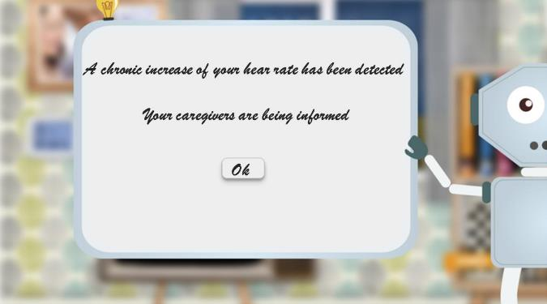

Figure 4: Notification representation example on user’s main screen (robot) notification panel (early version screenshot).

### References

**(ACSQHC, 2009)** Australian Commission on Safety and Quality in Healthcare, “Recognising and Responding to Clinical Deterioration: Use of Observation Charts to Identify Clinical Deterioration,” 2009.

**(APTA, 2016)** American Physical Therapy Association, “Vital Signs and Other Patient Screenings,” 2016. Available at: http://www.apta.org/PatientScreenings/. Accessed on: 17.03.2016

**(Griffiths et al., 2015)** R. Griffiths et al., “Vital signs monitoring in hospitals at night,” *Nursing Times*, 2015.

**(Boulanger & Toghill, 2009)** C. Boulanger, M. Toghill, “Ensuring best practice in observation to detect and report on patient deterioration,” *Nursing Times*, 2009.

**(Gonik & Rudolph, 2011)** C. J. Gonik, and J. L. Rudolph. “Vital Signs in Older Patients: Age-Related Changes,” *Journal of the American Medical Directors Association,* vol.12, no.5, pp. 337–343, 2011.

**(Jensen et al., 2013)** M. T. Jensen, et al., “Resting heart rate is a predictor of mortality in COPD,” *European Respiratory Journal*, pp. 1-9, 2013.

**(Aidar, 2009)** N.A. Aidar, et al., “ABPM in COPD patients with sleep desaturation. *Arquivos Brasileiros de Cardiologia*,” vol. 93, no.3, pp. 275-282, 2009.

**(Handa et al., 2012)** R. Handa, et al., “The role of heart rate variability in assessing the evolution of patients with chronic obstructive pulmonary disease,” *Romanian Journal of Internal Medicine*, vol. 50, no.1, pp. 83-91, 2012.

**(Cameron et al., 2012)** L. Cameron, et al., “The risk of serious adverse outcomes associated with hypoxaemia and hyperoxaemia in acute exacerbations of COPD,” *Postgrad Med Journal,*vol.vol. 88, no.1046, pp. 684-693, 2012.

**(Lellouche et al., 2013)** F. Lellouche, et al., “Optimal Oxygen Titration in Patients with Chronic Obstructive Pulmonary Disease: A Role for Automated Oxygen Delivery?,” *Canadian Respiratory Journal : Journal of the Canadian Thoracic Society*, vol. 20, no. 4, pp. 259–261, 2013.

**(Crossley et al., 2011)** GH Crossley, et al., “The CONNECT (Clinical Evaluation of Remote Notification to Reduce Time to Clinical Decision) Trial: The Value of Wireless Remote Monitoring With Automatic Clinician Alerts,” *Journal of the American College of Cardiology*, Vol. 57, no. 10, pp.1181-1189, 2011.

**(Rabbia et al., 2002)** F. Rabbia, et al.,” Assessing resting heart rate in adolescents: determinants and correlates,” *Journal of Human Hypertension*, vol. 16, pp. 327–332, 2002.

**(Nunan et al., 2010)** D. Nunan, et al., “A Quantitative Systematic Review of Normal Values for Short-term Heart Rate Variability in Healthy Adults,” *Pacing Clin Electrophysiol.*, vol. 33, no. 11, pp. 1407-1417, 2010.

**(AHA, 2015)** American Heart Association, “Understanding Blood Pressure Readings,” 2015.

**(Goodman et al., 2013)** R. A. Goodman, et al., “Defining and Measuring Chronic Conditions: Imperatives for Research, Policy, Program, and Practice,” Vol. 10, pp. 1-6, 2013.

**(WHO, 2016)** *Chronic diseases*, World Health Organization, retrieved: 18-03-2016.

**(Teguig et al., 2012)** D. Teguig, B. Scheers and V. Le Nir, "Data fusion schemes for cooperative spectrum sensing in cognitive radio networks," *Communications and Information Systems Conference (MCC)*, 2012 Military, Gdansk, 2012, pp. 1-7.

**(Chernick, 2011)** M. Chernick, “The Essentials of Biostatistics for Physicians, Nurses, and Clinicians,” *John Wiley & Sons*, pp. 49–50, 2011.

## Daily Physical Activity Lifestyle Reasoner

### Background

The field of daily physical activity monitoring and coaching has seen a huge increase in size and availability in recent years, although the topic has been explored already for a long time. An article by Kohl et al. **(Kohl et al., 2000)** reviews various techniques for assessing physical activity, citing articles that date back to 1971. In the sienctific domain, a huge boost to the field came from a number of much cited papers by Bouten et al. that describe the development of a tri-axial accelerometer based sensor for measuring daily physical activity **(Bouten et al., 1997)** and the validation of this technique by comparing the output of the sensor with energy expenditure measured with doubly labeled water **(Bouten et al., 1996)**. In a 7-day free-living experiment with 30 subjects, body movement was registered with a triaxial accelerometer and correlated to energy expenditure estimates such as doubly labeled water **(Speakman, 1998)** — considered to be the gold standard in energy expenditure estimation. A 0.73 correlation factor between overall physical activity level and sensor outputs was found.

Since the work of Bouten et al. in the late nineties, 3D accelerometers have become smaller, cheaper, and ubiquitously available. Research in the field has also seen a surge in recent years with numerous reviews being published on sensor development, e.g. **(Intille et al., 2012)**, assessment methodologies, e.g. **(Kohl et al., 2000)**, **(Plasqui et al., 2013)**, and **(Jones et al., 2013)** as well as classification of specific human activities from sensor data, e.g. **(Altun et al., 2010)**. The field has truly gained maturity with many commercial activity trackers that use accelerometers available on the market today such as FitBit, the WiThings sensors, and Misfit.

Although such commercial activities have made activity trackers available to the general public, and these companies focus in general on a good user experience through mobile apps and websites, their products are often not immediately applicable for use in elderly populations, or as preventive eHealth systems for chronic disease.

A physically active lifestyle is of utmost importance for the physical and mental health of the general population but also in specific, the elderly population. With this in mind, the World Health Organization **(WHO, 2011)** establishes a set of recommendations on physical activity for population aged 65 and above in order to improve fitness and reduce risk of, among others, depression and cognitive decline. Here we state a subset of these recommendations:

* Keep an active lifestyle while performing activities of daily living as transportation (e.g. walking or cycling), occupational, household tasks, games or planned exercise, in the context of daily, family and community activities.
* Physical fitness:
  + At least 150 minutes of moderate-intensity aerobic physical activity throughout the week OR do at least 75 minutes of vigorous aerobic physical activity throughout the week OR an equivalent combination of moderate- and vigorous-intensity activity;
  + When older adults cannot perform the recommended amounts of physical activity due to health conditions, they should be as physically active as their abilities and conditions allow.

Although such recommendations are useful for providing population wide recommendations – such as distributing printed materials from governmental bodies **(Dutton et al., 2008)**, **(Short et al., 2011)**, and **(Noar et al., 2007)**, a personal system such as eWALL is capable of providing much more personalized guidance and motivation. The daily physical activity lifestyle reasoner is a component that enables this level of personalization specifically for the area of everyday physical activity.

A focus on personalization was partly driven by the research on physical activity promotion described in a series of three PhD dissertations on Chronic Low Back Pain **(van Weering, 2011)**, Chronic Fatigue Syndrome **(Evering, 2013)** and Chronic Obstructive Pulmonary Disease **(Tabak, 2014)** where issues with compliance and long-term adherence are at least partly attributed to a lack of personalization in the tools used. Lack of compliance to motivational advice can be attributed to the high degree of heterogeneity within the target populations. It is widely believed that tailoring — or personalization — can help in increasing the effectiveness of technology that aims to achieve behavior change. In 2008, Hawkins et al. defined tailoring as “*any of a number of methods for creating communications individualized for their receivers, with the expectation that this individualization will lead to larger intended effects of these communications*” **(Hawkins et al., 2008)**. Since each individual is different, an intervention should therefore preferably use an approach that matches the individual user, concept better known as ’tailoring’.

A review by op den Akker et al., **(op den Akker et al., 2014)** identifies seven different tailoring concepts in the field of real-time physical activity coaching. By far the most obvious, and most used one is Feedback (presenting individuals with information about themselves), which is tightly linked and deemed much more effective when combined with Goal-Setting **(Locke & Latham, 2002)**. Figure 5 shows the tailoring model from **(op den Akker et al., 2014)** and shows how Goal-Setting can be used to enhance Feedback and subsequently the provisioning of Motivational Messages (MM). The various tailoring concepts described in Figure 5 are Context Awareness (CA), Adaptation (Ad), Goal-Setting (GS), User Targeting (UT), Inter-Human Interaction (IHI), and Feedback (FB), that all hold relationships to the provisioning of Motivational Messages (MM).

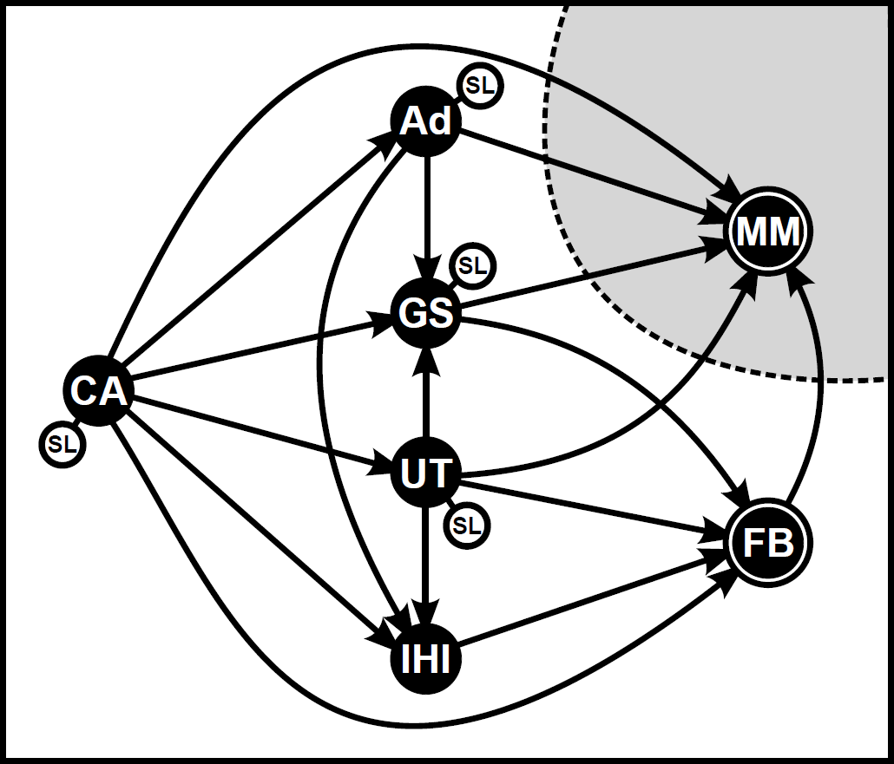

Figure 5: Tailoring model from (op den Akker et al., 2014) showing among others the path of Goal-Setting (GS) to Feedback (FB) to Motivational Messages (MM).

The Daily Physical Activity Lifestyle Reasoner has as main goal to calculate and keep track of a personalized (tailored) daily physical activity pattern for each individual user, which is subsequently used in the goal-setting IDSS component (see D4.2.3) to set a suitable goal for each user and for each specific day of the week. The daily physical activity lifestyle reasoner is part of the suite of services and applications in eWALL that support everyday physical activity, as shown in the overview in Figure 6. The acronyms used in Figure 6 are for Physical Activity (PA) and Main Screen (MS), which is the primary user interface on the eWALL touch screen device.

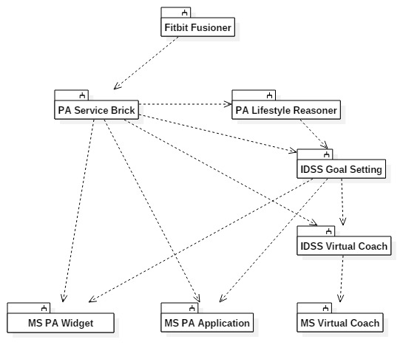

Figure 6: High level overview of the software modules involved in the daily physical activity service suite for eWALL.

As can be seen from Figure 6 the lifestyle reasoner is only a small part in a complex set of modules that provide the full daily activity service. Nevertheless, it provides a crucial level of intelligence that is required to provide appropriate motivation for our users. The generation of physical activity motivational messages provided by the IDSS Virtual Coach is heavily dependent on the availability of an appropriate goal. Messages are provided in direct relationship to this goal (e.g. ”You need an additional 3,459 steps to reach your goal for today!”). When this goal is much too challenging or much too simple to reach, motivation will fail **(Locke & Latham, 2002)**, regardless of any other intelligence applied in the coaching strategies. This individual goal, generated by the IDSS Goal-Setting module, and based on research described in **(Cabrita et al., 2014)**, takes as primary input the derived daily and weekly physical activity lifestyle pattern from the daily physical activity lifestyle reasoner. Goal-Setting remains an important topic in the field of physical activity promotion. A recent study by Herrmanny et al. shows that after a 12 week field study, half the users appreciated specific goal-setting support, especially when this support is personalized to the user **(Herrmanny et al., 2016)**.

It is not only important to reason on patterns of physical activity over longer periods as weeks or months but also within the day. Literature shows that COPD patients tend to be more active in the mornings when compared to afternoons or evenings. Detection of changes in the patterns of physical activity might be a signal for worsening (or improvement) of the health status. Therefore, a secondary intended purpose of the Daily Physical Activity Lifestyle reasoner is to analyze longitudinal data of daily physical activity distribution. Unforunately the data provided by in the eWALL platform (currently provided by the commercial Fitbit sensor) does not provide minute-by-minute values of data over the day, meaning that such an analysis is not possible in the current platform.

#### Functional description

The core functionality of this reasoner is to categorize each day of the week according to the amount of physical activity performed on those days. In other words, each day of the week is labeled according to the averaged amount of physical activity performed on that day. This algorithm should run at the end of each day and support the following steps:

1. Calculate the current average of daily physical activity per day of the week with Linear Weighted Moving Average (LWMA) after filtering for outliers. In this case, the more recent a value, the bigger its weight in the calculation of the current average;
2. Label the weekday according to the activity level category.

**Reasoner inputs**

* Physical activity data (*Service Brick – Physical Activity*).
* User information to determine the activity level, if necessary.

**Reasoner outputs**

The reasoner provides as output weighted averages and the date of last update for each weekday. For example, the output of the LR on Friday, December 5th at 16:11 could be:

Table 7: Example output data from the Physical Activity Lifestyle Reasoner.

|  |  |  |  |
| --- | --- | --- | --- |
| **Day** | **Class** | **Steps** | **Updated** |
| Monday | Inactive | 3536 | Tuesday, December 2 |
| Tuesday | Inactive | 3986 | Wednesday, December 3 |
| Wednesday | Normal | 6523 | Thursday, December 4 |
| Thursday | Active | 8569 | Friday, December 5 |
| Friday | Normal | 5986 | Saturday, November 29 |
| Saturday | Active | 9032 | Sunday, November 30 |
| Sunday | Inactive | 4736 | Monday, December 1 |
| Total | Normal | 4578 | Friday, December 5 |

### Implementation

The algorithms are currently implemented and serving the IDSS Goal-Setting reasoner described in D4.2.3. In the current implementation a date is considered an outlier if the physical activity is 0. A week day is classified as inactive, normal or active by taking the weighted average for that week day, and comparing it to the average and standard deviation of all dates that are not outliers. Ongoing and planned research will provide insights on the best algorithms for outlier detection and activity level categorization. Table 8 below summarizes some general implementation details regarding the Physical Activity Lifestyle Reasoner.

Table 8: General information on the Physical Activity Lifestyle Reasoner implementation.

|  |  |
| --- | --- |
| **Source code** | http://serv2.radio.pub.ro/gitlab/wp4/wp4project.git  lr-physical-activity |
| **Configuration** | Environment-dependent properties are set in:  src/main/resources/lr-physical-activity-*.properties |
| **Storage** | Data is stored in database lr_physical_activity_db (see properties) in MongoDB. |

The Physical Activity Lifestyle Reasoner stores intermittent and processed results in the MongoDB, the object storage database used in the eWALL Cloud Platform. Table 9 through Table 12 below show the data objects stored in the MongoDB.

Table 9: Description of "_table_metadata" MongoDB object for the Physical Activity Lifestyle Reasoner.

|  |
| --- |
| **_table_metadata** |
| Used for possible data model upgrades |

Table 10: Description of "activity" MongoDB object for the Physical Activity Lifestyle Reasoner.

|  |  |
| --- | --- |
| **activity_steps, activity_calories, activity_distance** | |
| user | username |
| date | yyyy-MM-dd, local timezone of the user |
| value | activity value in steps, calories, metres |
| category | if not an outlier: one of INACTIVE, NORMAL, ACTIVE  if an outlier: null |
| outlier | 0 if not an outlier, 1 if an outlier |

**Table 11: Description of "averages" MongoDB object for the Physical Activity Lifestyle Reasoner.**

|  |  |
| --- | --- |
| **averages_steps, averages_calories, averages_distance** | |
| user | username |
| weekDay | day of the week (1 = Monday, 7 = Sunday) |
| weightedAverage | the weighted average in steps, calories, metres |
| category | one of INACTIVE, NORMAL, ACTIVE |
| updated | yyyy-MM-dd, the date until which activity data has been processed to calculate the weighted average |

Table 12: Description of "processed" MongoDB object for the Physical Activity Lifestyle Reasoner.

|  |  |
| --- | --- |
| **processed** | |
| user | username |
| date | yyyy-MM-dd, the date until which the activity data has been processed (inclusive) |

#### Input

The Physical Activity Lifestyle Reasoner requires the following types of input data:

* Users. Retrieved from the profiling server: [profiling-server/users]. It reads username and timezoneid. If timezoneid is not defined, it will log a warning and fall back to the system time zone.
* Step count for a user at a specified date. Retrieved from service brick physical activity:  
   /v1/{userid}/movement?from={from}&to={to}&aggregation=1d

#### Output

The Physical Activity Lifestyle Reasoner has two JSON end-points. The ”lastupdate” endpoint provides the date until which the reasoner has processed data for a specific user (Table 13), and the ”activityweekpattern” provides the average physical activity data for each day of the week for a specific user (Table 14).

Table 13: Definition and example of the "lastupdate" endpoint for the Physical Activity Lifestyle Reasoner.

|  |
| --- |
| **lastupdate** |
| **Example**  Request:  http://ewall.radio.pub.ro/platform-dev/lr-physical-activity/lastupdate?userid=bilbo  Response:  {  "value":  {  "user":"bilbo",  "date":"2015-02-18"  }  }  **Request**  /lastupdate?userid={userid}  Parameters:   * userid: username   **Response**  The date until which the reasoner has processed activity data to generate a week pattern. The date is inclusive. It returns a JSON object with key ‘value’. The value is a record from database collection ‘processed’.  If no activity data has been processed, the value is null. |

Table 14: Definition and example of the "activityweekpattern_*" endpoint for the Physical Activity Lifestyle Reasoner.

|  |
| --- |
| **activityweekpattern_steps, calories, distance** |
| **Example**  Request:  http://ewall.radio.pub.ro/platform-dev/lr-physical-activity/activityweekpattern_steps?userid=bilbo  http://ewall.radio.pub.ro/platform-dev/lr-physical-activity/activityweekpattern_calories?userid=bilbo  http://ewall.radio.pub.ro/platform-dev/lr-physical-activity/activityweekpattern_distance?userid=bilbo  Response:  [  {  "user":"bilbo",  "weekDay":1,  "weightedAverage":6397,  "category":"NORMAL",  "updated":"2015-02-18"  },  ...  {  "user":"bilbo",  "weekDay":7,  "weightedAverage":6525,  "category":"NORMAL",  "updated":"2015-02-18"  }  ]  **Request**  /activityweekpattern_steps?userid={userid}&date={date}  /activityweekpattern_calories?userid={userid}&date={date}  /activityweekpattern_distance?userid={userid}&date={date}  Parameters:   * userid: username * date (optional): You can use this to retrieve week patterns from the past. It will return a pattern for which no activity data from after this date has been used to calculate the pattern. If omitted, it returns the most recent pattern.   **Response**  JSON array with physical activity information for each week day. Days without activity data are not included. Each element in the array is an object from database collection ‘averages’. |

### Reasoner output

The output of the daily physical activity lifestyle reasoner is used to feed the IDSS component responsible for setting personalized physical activity goals for each day of the week for individual users. Although the information from this reasoner could also be used to display directly to the user (to show how active you were compared to “normal”, similarly to the sleep application and sleep lifestyle reasoner), we have decided not to include this, as it made the daily physical activity application (My Activity book) too complicated for the added value.

### References

**(Kohl et al., 2000)** Kohl, H. W., Fulton, J. E. & Caspersen, C. J. (2000), ‘Assessment of Physical Activity among Children and Adolescents: A Review and Synthesis’, Preventive Medicine 31(2), 54–76.

**(Bouten et al., 1997)** Bouten, C. V. C., Koekkoek, K. T. M., Verduin, M., Kodde, R. & Janssen, J. D. (1997), ‘A Triaxial Accelerometer and Portable Data Processing Unit for the Assessment of Daily Physical Activity’, IEEE Transactions on Biomedical Engineering 44(3), 136–147.

**(Bouten et al., 1996)** Bouten, C. V. C., Verboeket-Van De Venne, W. P. H. G., Westerterp, K. R., Verduin, M. & Janssen, J. D. (1996), ‘Daily physical activity assessment: comparison between movement registration and doubly labeled water’, Journal of Applied Physiology 81(2), 1019–1026.

**(Speakman, 1998)** Speakman, J. R. (1998), ‘The history and theory of the doubly labeled water technique’, The American Journal of Clinical Nutrition 68(4), 932S–938S.

**(Intille et al., 2012)** Intille, S. S., Lester, J., Sallis, J. F. & Duncan, G. (2012), ‘New Horizons in Sensor Development’, Medicine & Science in Sports & Exercise 44(1 Suppl 1), S24–S31.

**(Plasqui et al., 2013)** Plasqui, G., Bonomi, A. G. & Westerterp, K. R. (2013), ‘Daily physical activity assessment with accelerometers: new insights and validation studies’, Obesity Reviews 14(6), 451–462.

**(Jones et al., 2013)** Jones, R. A., Hinkley, T., Okely, A. D. & Salmon, J. (2013), ‘Tracking Physical Activity and Sedentary Behavior in Childhood: A Systematic Review’, American Journal of Preventive Medicine 44(6), 651–658.

**(Altun et al., 2010)** Altun, K., Barshan, B. & Tunçel, O. (2010), ‘Comparative study on classifying human activities with miniature inertial and magnetic sensors’, Pattern Recognition 43(10), 3605–3620.

**(Dutton et al., 2008)** Dutton, G. R., Provost, B. C., Tan, F. & Smith, D. (2008), ‘A tailored print-based physical activity intervention for patients with type 2 diabetes’, Preventive Medicine 47(4), 409–11.

**(Short et al., 2011)** Short, C. E., James, E. L., Plotnikoff, R. C. & Girgis, A. (2011), ‘Efficacy of tailored-print interventions to promote physical activity: a systematic review of randomised trials’, The International Journal of Behavioral Nutrition and Physical Activity 8(1), 113.

**(Noar et al., 2007)** Noar, S. M., Benac, C. N. & Harris, M. S. (2007), ‘Does Tailoring Matter? Meta-Analytic Review of Tailored Print Health Behavior Change Interventions’, Psychological Bulletin 133(4), 673–693.

**(van Weering, 2011)** van Weering, M. G. (2011), Towards a New Treatment for Chronic Low Back Pain Patients - Using Activity Monitoring and Personalized Feedback, PhD thesis, University of Twente.

**(Evering, 2013)** Evering, R. M. H. (2013), Ambulatory Feedback at Daily Physical Activity Patterns: A Treatment for the Chronic Fatigue Syndrome in the Home Environment?, PhD thesis, University of Twente.

**(Tabak, 2014)** Tabak, M. (2014), Telemedicine for Patients with COPD - New Treatment Approaches to Improve Daily Activity Behaviour, PhD thesis, University of Twente.

**(Hawkins et al., 2008)** Hawkins, R. P., Kreuter, M. W., Resnicow, K., Fishbein, M. & Dijkstra, A. (2008), ‘Understanding tailoring in communicating about health’, Health Education Research 23(3), 454–466.

**(op den Akker et al., 2014)** Harm op den Akker, Valerie M. Jones, and Hermie J. Hermens, "Tailoring real-time physical activity coaching systems: a literature survey and model", in User Modeling and User-Adapted Interaction, Vol. 24 (5), pages 351-392, 2014.

**(Locke & Latham, 2002)** Locke, E. A. & Latham, G. P. (2002), ‘Building a Practically Useful Theory of Goal Setting and Task Motivation: A 35-Year Odyssey’, American Psychologist 57(9), 705–717.

**(Cabrita et al., 2014)** Miriam Cabrita, Harm op den Akker, Reinoud Achterkamp, Hermie Hermens and Miriam Vollenbroek-Hutten, "Automated Personalized Goal-Setting in an Activity Coaching Application", in Proceedings of the 3rd International Conference on Sensor Networks (SensorNets2014), Lisbon, Portugal, pages 389-396, January 2014.

**(WHO, 2011)** Global Recommendations on Physical Activity for Health – 65 years and above. (2011). Retrieved from <http://www.who.int/dietphysicalactivity/physical-activity-recommendations-65years.pdf?ua=1>

**(Herrmanny et al., 2016)** Katja Herrmanny, Jurgen Ziegler and Aysegul Dogangun, “Supporting Users in Setting Effective Goals in Activity Tracking”, in Proceedings of the 11th International Conference, PERSUASIVE 2016, Salzburg, Austria, April 5-7, 2016

## Mood Lifestyle Reasoner

### Background

Mood and the emotional state of the user are valuable characteristics of well-being. This reasoner is devoted to monitoring the mood of the user across time and register when the user is in a low or bad mood. Based on this, recommendations are issued that aim to improve the user’s mood. The main challenge in machine mood classification is that a specific user may express fairly complex and dynamic mood changes. These changes are usually conditional on a large set of possible states that the user can experience which imposes difficulties.

In order to model the user state of emotion a widely accepted model was used, that was proposed by Russell **(Russell, 1980)**. It reduces the emotional state space of the user to a two dimensional continuous space, where the x axis is the user’s valence and the other axis is the user’s level of arousal. Each state of user emotion is then injectively represented as a subset in this valence-arousal state space. In order to improve the representation we applied transformation from valence and arousal space to emotion space, hence obtaining a continuous time series of user emotions.

The stochastic analysis of the transformed emotion space of a user, showed that the time intervals between emotion state transitions satisfy the *memory-less* property. This allows for modeling the emotion state transitions as a continuous time, discrete state Markov chain. It must be noted at this point that, the chain can be conditioned upon user specifics. Similar approach was reported in the literature **(Chao, 2013)**. Hence, the user’s mood is defined as a function of the stationary distribution of the emotion state transitions.

### Implementation

The reasoner is activated at the end of the day and analysis is done based on the collected data through the day. This data is served by the *Socializing & Mood* service brick and is in the form of discrete valence and arousal measurements. If there is not enough data for reliable estimate of the mood a history data is requested for no more than 5 days and the mood is estimated based on this sample.

The sequence diagram of the mood calculation is depicted in Figure 7. As input are used the database connection, the date for the calculation and the user for whom we are calculating the mood. As a first step the mood data is requested form the *Socializing & Mood* service brick. The average valance is calculated based on this data for the specified date. This data is further utilized to calculate the trend of the mood. If there is no data for today, the algorithm uses as input the latest value of the Valence. If there is data for today, the Valence is compared with threshold 0 and based on the result, the mood is set either as positive or negative. This value is stored in the database and delivered by the reasoner upon request.



Figure 7: Sequence diagram of the core logic for the Mood Lifestyle Reasoner.

The user’s mood trend calculation is depicted in Figure 8 below. The trend calculation is based on data from the past 5 days. It uses an index table for coefficients to weigh the valence of the different days. The coefficients represent a difference calculation and depend on number of available data. Their values for the different days are presented on Table 15.

Table 15: Coefficients of difference scheme used for trend estimation.

|  |  |  |  |  |  |
| --- | --- | --- | --- | --- | --- |
| Available valence data | *Day “-1”* | *Day “-2”* | *Day “-3”* | *Day “-4”* | *Day “-5”* |
| **5 days** | **-0.2** | **-0.1** | **0** | **0.1** | **0.2** |
| **4 days** | **-0.3** | **-0.1** | **0.1** | **0.3** |  |
| **3 days** | **-0.5** | **0** | **0.5** |  |  |
| **2 days** | **-1** | **1** |  |  |  |

These coefficients are multiplied and summed (inner product) to the Valence data for the past days and the value is compared to 0. Depending on the comparison result the possible outcomes of the evaluation are: the mood is trend is INCREASING if the value is larger than zero, DECREASING if smaller than zero and has NO_CHANGE if the list is empty or the value after the calculation is zero.



Figure 8: Sequence diagram of mood trend calculation.

### Reasoner output

The reasoner is exposing one REST endpoint which is serving the applications and the wellbeing ads. The parameters, with their possible values, returned by the endpoint are presented on the table below (see Table 16).

Table 16: REST end-point definition for the Mood Lifestyle Reasoner.

|  |  |
| --- | --- |
| **mood4Period** | |
| user | username |
| mood | The type of user’s mood. It can be *“positive”*, *“negative”* or *“neutral”* |
| trend | User’s mood trend: “*increasing*”, “*decreasing*” or “*nochange*” |

### References

**(Russell, 1980)** J. A. Russell, A circumplex model of affect. Journal of personality and social psychology, vol. 39,no. 6, p. 1161, 1980.

**(Chao, 2013)** L. Chao, J. Tao, M. Yang, and Y. Li, Bayesian inference based temporal modeling for naturalistic affective expression classification, in Affective Computing and Intelligent Interaction (ACII), 2013 Humane Association Conference on. IEEE, 2013, pp. 173178.

## Sleep Lifestyle Reasoner

### Background

The *My Sleep* set of eWALL services monitors and reasons on the sleeping behavior of the primary user and shows relevant information to both primary and secondary users. It serves two main purposes: (1) to provide detailed information regarding each individual night of sleep, and (2) to combine medium and long term information to define patterns and detect deviations beyond these patterns. As one night of bad sleep does not imply sleeping problems, detection of sleeping disorders calls for collection of longitudinal data. Context information should also be included to better reason about the sleeping behavior (e.g. temperature and humidity in the room, and surrounding noise). This application serves the needs and requirements of our three target groups.

The *Sleep Lifestyle Reasoner* combines information from the *My Sleep* application and *My Activity* in order to provide meaningful information about changes in the sleeping period over time. The outcome of this reasoner is shown to the user in the My Sleep Application and is also used by the *Personal Daily Support Service*.

#### Age related impairments

It is estimated that around twenty five per cent of elderly people worldwide have sleeping disorders **(Ancoli-Israel, 2009)**. For example, in the Netherlands 20-30% of the adults suffer from sleeping problems. Only 10-20% of these people will go to visit a physician **(Knuistingh et al., 2004)**. Bad nights of sleep make people feel tired during the day, lose their enthusiasm and get easily irritated. Insufficient sleep is also associated with significant morbidity and increased mortality **(Dew et al., 2003)**, and with an increased risk of falls **(Brassington et al., 2000)**. People with poor sleep are more likely to be involved in car accidents and accidents at home, compared to good sleepers **(Léger et al., 2002)**, **(Philip et al., 2010)**. Insomnia becomes a more common problem with age.

The added-value of the *My Sleep Application* for the general elderly population is to support self-awareness about each individual sleeping patterns and create alerts whenever the sleeping behavior deviates from expected. Furthermore, My Sleep Application can support the users improving their quality of sleep by instructing into what is known as sleep hygiene, i.e. a set of good practices regarding behavior in the bedroom and in the hours leading up to sleep **(Stepanski et al., 2003)**.

In particular, the *Sleep Lifestyle Reasoner* allows the detection of minor or major deviations in the normal sleep patterns, that might indicate changes in the health status of the older adults, maybe even before they realize it.

#### Users with Mild Cognitive Impairments

Along with the common sleep disorders related to the ageing population, detection of sleep disturbances in elderly suffering from Mild Cognitive Impairments may be a predictive marker of the conditions’ progression **(Hita-Yañez et al., 2013)**, **(da Silva et al., 2015)**. An irregular sleep–wake pattern can reflect the level of cognitive impairment. As the disease progresses, more severe sleep disturbances develop which affect the continuity of nighttime sleep, alertness during the day and overall wellbeing. The evaluation of sleep disturbances can help toward a proper diagnosis and a better understanding of the cognitive condition of the person with cognitive impairments **(Nikamalfard et al., 2011)**.

The sleeping behavior of an patient suffering from Mild Cognitive Impairments (MCI) is very important not only because of the sleeping itself, but also because of everything that happens during the night period. MCI patients might experience abnormalies in the circadian rhythms (i.e. daily-night rhythms), one characteristic commonly seen when the disease progresses to dementia **(Guarnieri et al., 2015)**, **(Ortiz-Tudela et al., 2014)**. As the condition progresses, patients can find themselves awake during the night doing their daily duties (i.e. *wandering*), as they do not have the perception that that is not expected from them during the night. The eWALL supports these patients, and respective caregivers, by providing subtle messages aiming at bringing the patient back to bed (*Personal Daily Support System*). Also, during these daily-night shift patterns, MCI patients are often found leaving the house. As one sporadic case does not suffice for diagnosis, the *Sleep Lifestyle Reasoner* assumes here a crucial role.

Literature suggests discrepancies between subjective and objective measures of sleep parameters with MCI patients, when compared to healthy subjects **(Hita-Yañez et al., 2013)**. Therefore, eWALL also analyzes deviations between self-perceived and objective sleep quality as it can be an indicator of progression of the condition.

Combined with the above mentioned regarding the general older population, the added value of the *My Sleep Application* for the MCI target group is to support the primary user in the self-management of his/her condition and also to support the secondary user (i.e. informal caregiver) providing insights on the sleeping behavior of the patient and providing alerts whenever justifiable.

The *Sleep Lifestyle Reasoner* is very important for the MCI target group considering that, combining data from several applications, it allows detection of minor deviations in the sleeping patterns, being a good indication of the progression of the cognitive impairments.

#### Users suffering from COPD

Elderly with chronic diseases commonly experience higher rates of sleep problems than those without **(Foley et al., 2004)**. The quality of sleep of COPD patients is considerably impaired **(Agusti et al., 2011)**, with more than 50% of the patients reporting sleep-related complaints **(Klink et al., 1994)**. Elderly suffering from COPD might also indicate specific sleep disturbances and report a total sleep time which can be considerably lower **(Valipour et al., 2011)**. This can be explained by the fact that people with COPD are woken up many times during the night, which leads to a reduction in sleep efficiency **(Klink et al., 1994)**. The biggest value of the *My Sleep Application* to COPD patients is to, based on their personal rhythms and problems, provide recommendations to improve sleep hygiene and coach the users into a healthy sleeping behavior.

The Sleep Lifestyle Reasoner, by detecting deviations from normality, supports COPD patients in the self-management of their condition. Also, as the sleeping period becomes, for exampe, more interrupted, the patient is alerted and it might lead him to be directed to a healthcare professional to control his / her condition.

In order to meet the requirements of the three target groups, a set of different modules were defined. For each of these modules an appropriate scenario can be found below, and their associated requirements described. Some of the requirements based on the scenario’s below are repeated. Since it is not yet clear if all functionality will be developed, each functionality description should be complete in and of it’s own.

#### Scenarios

##### Long-term deviations in the time the user falls asleep

The eWALL detects that Henry falls asleep later and later during the last couple of weeks. Henry’s daughter receives a notification on the eWALL informal caregiver application, informing her about this fact. She can say that everything is “Ok” and ignore the message, or she can decide whether, from that day on, she wants to enable daily notifications about the sleeping time of her father. She chooses the second option. The next morning she receives a notification saying that Henry went to sleep at 22h30, his normal time. After one week of receiving information about the times that her father went to sleep, Sarah decides that the pattern is back to normal and she disables the daily notifications about the sleeping time of her father. eWALL does not send any more daily notifications of this type until a significant change is detected again.

Note: The same scenario can take place if Henry goes to sleep earlier and earlier.

*Requirements*:

* The *Sleep Lifestyle Reasoner* must store the time when the user falls asleep. This information is obtained from Fitbit in the *My Activity Application.*
* The *Sleep Lifestyle Reasoner* must calculate a trend in the falling asleep time.
* The *Sleep Lifestyle Reasoner* must classify the current situation as normal, improving or worsening.
* (Personal Daily Support Service) If the trend in the falling asleep time passes a pre-defined threshold, the PeDaS sends a notification to caregiver and / or to the user.
* (Caregiver Application) The Caregiver has the possibility to ignore the message or to decide to be informed every night about the time when the primary user fell asleep.
* (Caregiver Application) The caregiver can decide at any time to stop with the daily information.

##### Long-term deviations in the duration of sleep of the user

The eWALL detects that Henry is sleeping less and less in the last weeks. Sarah receives a notification in her eWall informal caregiver application alerting for this fact. In the app, she can simply press “Ok” and nothing will happen, or she can decide that she wants to be informed every day about the sleeping times of her father. As she is very worried, she decides to take a look at the last night of sleep of her father. She sees that Henry was awake three times during the night, and in one of these he was walking around the house for more than 20 minutes. Sarah is worried and decides to visit her father.

*Requirements:*

* The *Sleep Lifestyle Reasoner* must store the duration of sleep per night. This information is obtained from Fitbit in *My Activity Application.*
* The *Sleep Lifestyle Reasoner* must calculate a trend in the duration of sleep over time.
* The *Sleep Lifestyle Reasoner* must classify the current situation as normal, improving or worsening.
* (Personal Daily Support Service) If the trend in the duration of sleep passes a pre-defined threshold, the PeDaS sends a notification to caregiver and / or to the user.
* (Caregiver Application) The caregiver has the possibility to ignore the message or to decide to be informed every night about the duration of sleep of the primary user.
* (Caregiver Application) From the notification, the caregiver can open the information about the previous night of sleep of the primary user.
* (Caregiver Application) The caregiver can decide at any time to stop with the daily information.

##### Long-term deviations in the number of times that the user wanders during the night at home

It is the third time this week that Henry wanders around the house for more than 2 times per night. Sarah receives a message informing her about this fact. She can decide to ignore and do nothing about it, or to receive daily information about the number of times her father was wandering inside the house. Sarah can also decide to take a look at the detailed information about her father’s last night of sleep. Sarah decides to call Henry to be sure that everything is okay.

*Requirements:*

* The eWALL platform must know whether or not the user left the house during the night.
* The *Sleep Lifestyle Reasoner* must store the number of times that the user is wandering inside the house per night. This information is obtained from Fitbit in the *My Activity Application*. Every time there are steps measured during sleeping periods and eWALL did not detect that the user left the house, the user is considered to be wandering around the house.
* The *Sleep Lifestyle Reasoner* must classify the current situation as normal, improving or worsening.
* (Personal Daily Support Service) If the number of times the user was wandering around the house during the night passes a pre-defined threshold, the PeDaS sends a notification to caregiver and / or to the user.
* (Caregiver Application) The caregiver has the possibility to ignore the message or to decide to be informed every night about the number of times the user was wandering inside the house during that night.
* (Caregiver Application) From the notification, the caregiver can open the information about the previous night of sleep of the primary user.
* (Caregiver Application) The caregiver can decide at any time to stop with the daily information.

##### Long-term deviations in the duration of the times when the user wanders during the night at home

Henry has been wandering inside the house during the night for longer periods of time during the last week. First it started with 5-10 minutes but lately he wanders 30 minutes or even 45 minutes walking around the house during the night. Then he goes back to sleep. Sarah receives a notification on her caregiver application. Sarah can decide to ignore this message or to receive daily information about the duration of the times when Henry wanders at home during the night. She chooses the second option.

*Requirements*:

* The eWALL platform must know whether or not the user left the house during the night.
* The *Sleep Lifestyle Reasoner* must store the duration of the time intervals when the user is wandering inside the house per night. This information is obtained from Fitbit in the *My Activity Applica*tion. Every time there are steps measured between sleeping periods, while eWALL did not detect the user leaving the house, the user is considered to be wandering around the house.
* The *Sleep Lifestyle Reasoner* must classify the current situation as normal, improving or worsening.
* (Personal Daily Support Service) If the duration of the time intervals when the user is wandering around the house during the night passes a pre-defined threshold, the PeDaS sends a notification to the caregiver and / or to the user.
* (Caregiver Application) The caregiver has the possibility to ignore the message or to decide to be informed every night about the duration of the time intervals when the user is wandering inside the house during that night.
* (Caregiver Application) From the notification, the caregiver can open the information about the previous night of sleep of the primary user.
* (Caregiver Application) The caregiver can decide at any time to stop with the daily information.

##### Long-term deviations in the number of times that the user wanders during the night outside the home

It is the third time this week that Henry wanders outside the home during the night. Sarah receives a notification in her app. She is very worried about this fact so decides to call Henry immediately. Sarah also enables the option to receive daily information if her father left the house during the night.

*Requirements:*

* The eWALL platform must know if the user left, or not, the house during the night.
* The *Sleep Lifestyle Reasoner* must store the amount of times the user leaves the house during the night.
* The *Sleep Lifestyle Reasoner* must classify the current situation as normal, improving or worsening.
* (Personal Daily Support Service) If the amount of times the user left the house during the night in the last seven days increases above a pre-defined threshold, the PeDaS sends a notification to caregiver and / or to the user.
* (Caregiver Application) Caregiver has the possibility to ignore the message or to decide to be informed every time the user leaves the house during the night.
* (Caregiver Application) From the notification, caregiver can open the information about the previous night of sleep of the primary user.
* (Caregiver Application) Caregiver can decide at any time to stop with the daily information.

##### Long-term deviations in the duration of the times when the user wanders during the night outside the home

It is normal that Henry wakes up during the night, takes a walk, and then returns to sleep. However, what started with 10-minute-walk, evolved to 30 minutes or even 45 minutes outside the house during the night. This is above the threshold defined by Sarah. The next morning Sarah receives a notification in her caregiver app informing that her father has been spending more and more time outside the house during the night. Sarah enables the option to receive daily notifications if her father stays out of the home for more than 30 minutes.

*Requirements:*

* The eWALL platform must know if the user left, or not, the house during the night.
* The *Sleep Lifestyle Reasoner* must store the duration of the times when the user wanders outside the house during the night.
* The *Sleep Lifestyle Reasoner* must classify the current situation as normal, improving or worsening.
* (Personal Daily Support Service) If the duration of the times the user wanders outside the house during the night increases above a pre-defined threshold, the PeDaS sends a notification to caregiver and / or to the user.
* (Caregiver Application) Caregiver has the possibility to ignore the message or to decide to be informed every time the user leaves the house during the night.
* (Caregiver Application) From the notification, caregiver can open the information about the previous night of sleep of the primary user.
* (Caregiver Application) Caregiver can decide at any time to stop with the daily information.

##### Long-term deviations in the self-perception of quality of sleep

Henry has been waking up restless with the feeling that he has not slept enough. When trying to remain in bed longer in the mornings, he doesn’t fall asleep again and eventually decides to get up. The latest answers to the sleeping questionnaire have reflected that. Sarah receives a notification about the fact that her father has constantly reported bad sleep lately. She knows that Henry is worried about the upcoming medical visit and decides to ignore the notification. No action from eWALL is taken. Also Henry receives a notification asking if he would like to know more information about sleeping hygiene. Henry feels tired and decides he wants to see the information. eWALL provides Henry with some tips on how to help him sleep better (e.g. reduce caffeine intake and be active during the day).

*Requirements:*

* The eWALL user interface should provide regular questionnaires to assess perceived quality of sleep.
* The *Sleep Lifestyle Reasoner* must store the ratings given by the user on the perceived quality of sleep.
* (Personal Daily Support Service) If the rating given by the user is below a pre-defined threshold for more than 3 times in the last 7 ratings, a message to the informal caregiver should be provided.
* (Caregiver Application) The caregiver has the possibility to ignore the message or to decide to receive information every time the primary user reports on sleep quality.
* (Caregiver Application) From the notification, the caregiver can open the information about the previous night of sleep of the primary user.
* (Caregiver Application) The caregiver can decide at any time to stop with the regular information.
* (Personal Daily Support Service) If the rating given by the user is below a pre-defined threshold for more than 3 (?) times in the last 7 (?) ratings, a message should be provided to the user asking if he wants more information about sleep hygiene.
* (Personal Daily Support Service) If the user says that he wants more information, eWALL should provide several tips on how to improve sleep quality.
* (Personal Daily Support Service) If the user does not want to receive advice, eWALL should immediately stop the interaction.

##### Long-term deviations in the objective sleep quality

eWALL has detected that the quality of sleep of Henry, obtained from the objective data collection, is degrading. Sarah receives a notification in her caregiver application alerting her of this fact. She decides to ignore it and passes by her father’s house to see if all sensors are placed correctly.

*Requirements*:

* The *Sleep Lifestyle Reasoner* has to store a value for quality of sleep per night based on information from the *My Sleep Application*.
* (Personal Daily Support Service) If the objective quality of sleep goes below a pre-defined threshold for more than 3 nights in a row the informal caregiver should be notified.
* (Caregiver Application) The caregiver has the possibility to ignore the message or to decide to receive daily information on the previous night of sleep.
* (Caregiver Application) From the notification, the caregiver can open the information about the previous night of sleep of the primary user.
* (Caregiver Application) The caregiver can decide at any time to stop with the regular information.

##### Long-term deviations between the subjective (self-perception) and objective of quality of sleep

eWALL has detected that the quality of sleep of Henry, obtained from the objective data collection, is degrading. However, the self-perceived ratings of quality of sleep do not show any difference. Sarah is notified about this fact.

*Requirements*:

* The eWALL user interface should provide regular questionnaires to assess perceived quality of sleep.
* The *Sleep Lifestyle Reasoner* must store a value for quality of sleep per night based on information from the *My Sleep Application*.
* The *Sleep Lifestyle Reasoner* has to store the ratings given by the user on the perceived quality of sleep (*My Sleep Application*).
* The *Sleep Lifestyle Reasoner* must store a variable that relates the self-perceived quality of sleep with the quality of sleep obtained from the objective measurements.
* The *Sleep Lifestyle Reasoner* must classify the current situation as normal, improving or worsening.
* (Personal Daily Support Service) If the previous variable goes beyond a pre-defined threshold, the informal caregiver should be notified.
* (Caregiver Application) The caregiver has the possibility to ignore the message or to decide to receive information on the previous night of sleep every time the primary user reports on his self-perceived quality of sleep.
* (Caregiver Application) From the notification, the caregiver can open the information about the previous night of sleep of the primary user.
* (Caregiver Application) The caregiver can decide at any time to stop with the regular information.

### Implementation

**Functionality description**

Figure 9 illustrates the data flow regarding the sleep from sensor data acquisition to the Sleep Lifestyle reasoner. The sensors existent in the room (e.g. microphone, accelerometer and bed pressure) provide raw data to the Daily Functioning Service Brick, which perform pre-processing algorithms as filtering. The Sleep IDSS reasoner (WP4) can then combine the data from the SB retrieved from several service endpoints and infer on the sleep period. The Sleep Lifestyle Reasoner runs once a day (e.g. at 13:00) and, if new data is detected, creates updated averages of each one of the pre-defined parameters related to the sleeping pattern of the user. Averages are calculated using Linear Weighted Moving Average (LWMA), giving bigger weight to more recent values. Outliers are filtered and not considered in the calculations. The optimal algorithm for outlier detection needs research and testing.

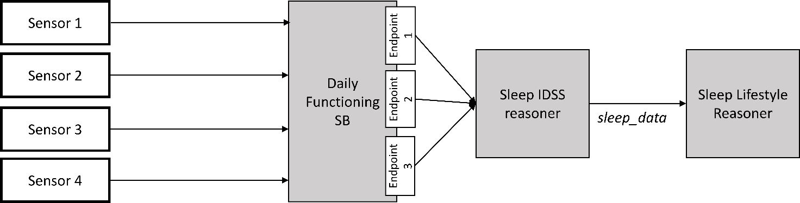

Figure 9: Ideal conceptualization of data flow from raw data acquired by sensors to *sleep_data* used by the lifestyle reasoner.

**Reasoner inputs**

Sleep IDSS reasoner provides data regarding the last night of sleep (currently through Sleep Service Brick).

**Reasoner outputs**

Weighted average in minutes of each parameter of sleep per day of the week till the current moment. For example, the output of the Lifestyle Reasoner on Friday, December 5th. 16:11 could be, as show in Table 17.

Table 17: Example output of the Sleep Lifestyle Reasoner.

|  |  |  |  |  |
| --- | --- | --- | --- | --- |
| **Day** | **Asleep time (min)** | **Wake time (min)** | **Total sleep time (min)** | **Last update** |
| Monday | 1398 | 431 | 473 | Tuesday, December 2 |
| Tuesday | 1251 | 400 | 589 | Wednesday, December 3 |
| Wednesday | 1349 | 463 | 554 | Thursday, December 4 |
| Thursday | 1298 | 435 | 577 | Friday, December 5 |
| Friday | 1523 | 425 | 342 | Saturday, November 29 |
| Saturday | 1498 | 512 | 454 | Sunday, November 30 |
| Sunday | 1347 | 514 | 607 | Monday, December 1 |
| Average | 1381 (23:01) | 454 (07:34) | 451 (8h34m) | Thursday, December 4 |

**Applications served**

The data from the reasoner is used to provide long-term overviews of sleeping patterns in the *Sleep Monitoring Application*.

**Implementation**

Table 18: General information on the Sleep Lifestyle Reasoner implementation.

|  |  |
| --- | --- |
| **Source code** | http://serv2.radio.pub.ro/gitlab/wp4/wp4project.git  lr-sleep-monitor |
| **Configuration** | Environment-dependent properties are set in:  src/main/resources/lr-sleep-monitor*.properties |
| **Storage** | Data is stored in database lr_sleep_monitor_db (see properties) in MongoDB. |

The Sleep Lifestyle reasoner gets data from the Sleep IDSS reasoner, which uses sleep data from a Fitbit tracker. The Sleep Lifestyle reasoner runs at 13:00 every day and requests the data for the past night. Based on the data received, it infers the following parameters:

* **bedOnTime**: Time the user went to bed, in minutes since 0:00 of the day preceding the night. If the user went to sleep after midnight, this will be more than 24 hours. DST is not taken into account. For example in London time 2015-03-29 22:00:00 is 21 hours after midnight, but this parameter will be 22 hours (in minutes);
* **bedOffTime**: Time the user got out of bed, in minutes since 0:00 of the day following the night. If the user woke up before midnight, this will be less than 0. DST is not taken into account. For example in London time 2015-03-29 08:00:00 is 7 hours after midnight, but this parameter will be 8 hours (in minutes);
* **totalSleepTime**: Total duration in minutes that the user was in bed during the night;
* **frequencyWakingUp**: Number of times that the user woke up during the night;
* **sleepEfficiency**: The sleep efficiency in percent.



Figure 10: Current data flow from raw data acquired by sensors to *sleep_data* used by the lifestyle reasoner.

The Sleep Lifestyle Reasoner stores intermittent and processed results in the MongoDB. Table 19 through Table 23 below show the data objects stored in the MongoDB.

Table 19: Description of "_table_metadata" MongoDB object for the Sleep Lifestyle Reasoner.

|  |
| --- |
| **_table_metadata** |
| used for possible data model upgrades |

Table 20: Description of "night_sleep_data" MongoDB object for the Sleep Lifestyle Reasoner.

|  |  |
| --- | --- |
| **night_sleep_data** | |
| user | username |
| date | date following the night to which this period belongs  yyyy-MM-dd, local time zone of the user |
| sleepParameters | JSON object with a raw string value for each sleep parameter:   * bedOnTime: ISO date/time string * bedOffTime: ISO date/time string * totalSleepTime: minutes * frequencyWakingUp: number of times the user woke up * sleepEfficiency: percent |

Table 21: Description of "sleep_updated" MongoDB object for the Sleep Lifestyle Reasoner.

|  |  |
| --- | --- |
| **sleep_updated** | |
| user | username |
| date | date following the night until which sleep data has been retrieved and stored in collection ‘night_sleep_data’.  yyyy-MM-dd, local time zone of the user |

Table 22: Description of "averages" MongoDB object for the Sleep Lifestyle Reasoner.

|  |  |
| --- | --- |
| **averages** | |
| user | username |
| weekDay | day of the week (1 = Monday, 7 = Sunday). The average is for the night that precedes this day. |
| parameter | parameter name. For possible values, see the section about sleep parameters below. |
| weightedAverage | weighted average value. See the section about sleep parameters for the interpretation of this value. |
| category | one of BELOW_NORMAL, NORMAL, ABOVE_NORMAL |
| updated | yyyy-MM-dd, the date following the night until which sleep data has been processed to calculate the weighted average, local time zone of the user |

Table 23: Description of "sleep_processed" MongoDB object for the Sleep Lifestyle Reasoner.

|  |  |
| --- | --- |
| **sleep_processed** | |
| user | Username |
| date | date following the night until which sleep data has been processed to calculate a week pattern, as stored in collection ‘averages’.  yyyy-MM-dd, local time zone of the user |

**Input**

* Users. Retrieved from the profiling server: profiling-server/users
* Sleep data. Retrieved from the Sleep IDSS reasoner:  
  idss-sleep-reasoner/sleepdata?username={username}&from={from}&to={to}

**Output**

The Sleep Lifestyle Reasoner has three JSON end-points. The ”lastupdate” endpoint provides the date until which the reasoner has processed data for a specific user (Table 24), the ”sleepweekpattern” provides the averaged sleep data for each day of the week for a specific user (Table 25) and a specific ’update’ date. Finally, the ”wakeuproutine” end-point provides a simplified endpoint for retrieving the times at which the user normally wakes up on each specific day of the week (see Table 26).

Table 24: Definition and example of the "lastupdate" endpoint for the Sleep Lifestyle Reasoner.

|  |
| --- |
| **lastupdate** |
| **Example**  Request:  http://ewall.radio.pub.ro/platform-dev/lr-sleep-monitor/lastupdate?userid=bilbo  Response:  {  "value":  {  "user":"bilbo",  "date":"2015-03-02"  }  }  **Request**  /lastupdate?userid={userid}  Parameters:   * **userid**: username   **Response**  The date following the night until which the reasoner has processed sleep data to calculate a week pattern.  It returns a JSON object with key ‘value’. The value is a record from database collection ‘sleep_processed’.  If no sleep data has been processed, the value is null. |

Table 25: Definition and example of the "sleepweekpattern" endpoint for the Sleep Lifestyle Reasoner.

|  |
| --- |
| **sleepweekpattern** |
| **Example**  Request:  http://ewall.radio.pub.ro/platform-dev/lr-sleep-monitor/sleepweekpattern?userid=bilbo  Response:  {  "user":"bilbo",  "days":  [  {  "weekDay":1,  "parameters":  [  {  "parameter":"frequencyWakingUp",  "weightedAverage":1,  "category":"NORMAL"  },  {  "parameter":"sleepEfficiency",  "weightedAverage":76,  "category":"NORMAL"  },  {  "parameter":"totalSleepTime",  "weightedAverage":560,  "category":"NORMAL"  },  {  "parameter":"bedOnTime",  "weightedAverage":1349,  "category":"NORMAL"  },  {  "parameter":"bedOffTime",  "weightedAverage":478,  "category":"NORMAL"  }  ]  },  ...  {  "weekDay":7,  "parameters":  [  {  "parameter":"frequencyWakingUp",  "weightedAverage":1,  "category":"NORMAL"  },  …  ]  }  ],  "updated":"2015-03-02"  }  **Request**  /sleepweekpattern?userid={userid}&date={date}  Parameters:   * **userid**: username * **date** (optional): You can use this to retrieve week patterns from the past. It will return a pattern for which no sleep data from after this date has been used to calculate the pattern. If omitted, it returns the most recent pattern.   **Response**  JSON object with the following keys:   * **user**: username * **days**: array with a pattern for each week day. Days without data are not included. Each element is an object with the following keys:   + **weekDay**: the week day (1 is Monday, 7 is Sunday)   + **parameters**: array with values for various sleep parameters. Each element is an object with the following keys:     - **parameter**: parameter name. For possible values, see the section about sleep parameters below.     - **weightedAverage**: weighted average value. See the section about sleep parameters for the interpretation of this value.     - **category**: classification of the weighted average value, one of BELOW_NORMAL, NORMAL, ABOVE_NORMAL. * **updated**: the date following the night until which sleep data has been processed to calculate this week pattern, formatted as yyyy-MM-dd. This may be null if no data is available. |

Table 26: Definition and example of the "wakuproutine" endpoint for the Sleep Lifestyle Reasoner.

|  |
| --- |
| **wakeuproutine** |
| **Example**  Request:  http://ewall.radio.pub.ro/platform-dev/lr-sleep-monitor/wakeuproutine?userid=bilbo  Response:  {  "wakeUpTimeMonday": 360,  "wakeUpTimeTuesday": 298,  "wakeUpTimeWednesday": 323,  "wakeUpTimeThursday": 329,  "wakeUpTimeFriday": 342,  "wakeUpTimeSaturday": 419,  "wakeUpTimeSunday": 366  }  **Request**  /wakeuproutine?userid={userid}  Parameters:   * **userid**: username   **Response**  A total of seven values indicating the time at which the user normally wakes up on the specified days of the week in minutes since midnight (e.g. 366 = 06:06). |

### Reasoner output

The *Sleep Lifestyle Reasoner* generates data that is shown to the users by the following applications:

* *My Sleep Application*, providing patterns of sleep over time (e.g. usual time of going to sleep or usual sleep location);
* *Personal Daily Support Service*, whenever a notification should be provided to the user;
* *Caregiver Application*, whenever the caregiver should be informed about significant changes in the sleeping patterns of the primary user.

The following figures show examples of the integration of information provided by the sleep lifestyle reasoner in order to deliver a meaningful explanation for the primary user. In Figure 9 the “My Sleep” application is shown on the opening page that shows information regarding last night’s sleep. The “usual” behavior show in this figure originates from the sleep lifestyle reasoner.



Figure 11: My Sleep application showing an overview of last night’s sleep including the output of the Sleep Lifestyle Reasoner.

Based on requirements from user testing, the elderly participants who shown interest in this functionality requested an easy to understand overview of the last night of sleep, compared to their usual behavior, but also a weekly overview. The weekly overview is a new feature of the sleep application and it was considered essential by the test participants, as it would display an easy to understand overview of the differences in sleep behavior, compared to their average habit (see Figure 10, Figure 11, and Figure 12 below).



Figure 12: My Sleep application’s second page, showing graphical representations of weekly overviews of sleep data (sleep efficiency is shown versus “normal” sleep efficiency for the user).

In Figure 11 below, the same weekly graphical overview is shown for the total sleep time per night (in hours).

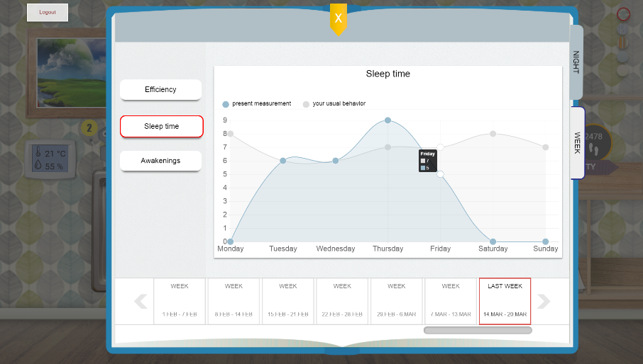

Figure 13: My Sleep application’s graphical weekly overview of total sleep time, showing the weekly behavior on top of the user’s usual behavior.

The final figure below (Figure 12) shows the same graphical representation of the number of awakenings (sleep interruptions) per night, compared to the user’s usual behavior.

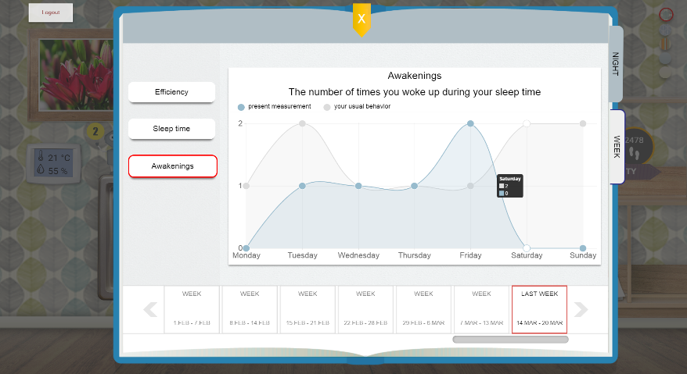

Figure 14: My Sleep application’s graphical weekly overview of number of awakenings (sleep interruptions) per night, showing the weekly behavior on top of the user’s usual behavior.

Besides these visual integrations into the main screen, the Sleep Lifestyle Reasoner also provides input to the Personal Daily Support Service (or Robin, the Virtual Coach) in order to personalize certain behaviors. Every morning, Robin will launch the ”Good Morning” dialogue for the user. The time at which this dialogue can appear is based on the user’s daily wake up routine (i.e. it only appears within 120 minutes after the user’s normal wake up time for the specific day). See Figure 13 below for an example of the Good Morning dialogue.

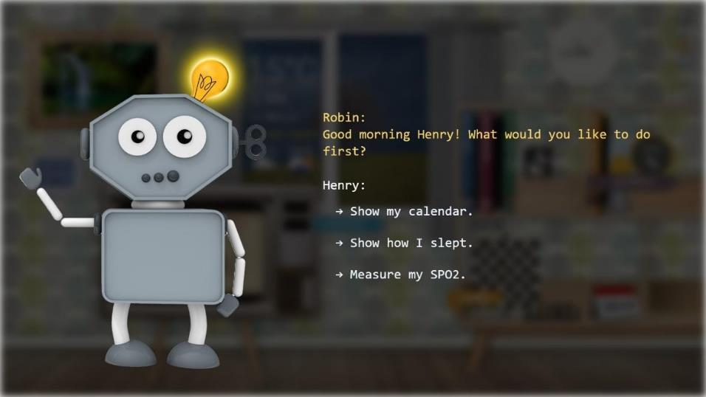

Figure 15: Screenshot of the “Good Morning” dialogue from Robin, the Virtual Coach, presented to the user based on his normal wake up routine.

### References

**(Agusti et al., 2011)** Agusti, A. et al. 2011. “Night-Time Symptoms: A Forgotten Dimension of COPD.” *European Respiratory Review* 20(121): 183–94.

**(Ancoli-Israel, 2009)** Ancoli-Israel, Sonia. 2009. “Sleep and Its Disorders in Aging Populations.” *Sleep Medicine* 10: S7–11. http://dx.doi.org/10.1016/j.sleep.2009.07.004.

**(Brassington et al., 2000)** Brassington GS, King AC, Bliwise DL. Sleep problems as a risk factor for falls in a sample of community-dwelling adults aged 64-99 years. J Am Geriatr Soc. 2000;48:1234-1240.

**(Dew et al., 2003)** Dew MA, Hoch CC, Buysse DJ, et al. Healthy older adults' sleep predicts all-cause mortality at 4 to 19 years of follow-up. Psychosom Med. 2003;65:63-73.

**(Foley et al., 2004)** Foley, Daniel, Sonia Ancoli-Israel, Patricia Britz, and James Walsh. 2004. “Sleep Disturbances and Chronic Disease in Older Adults: Results of the 2003 National Sleep Foundation Sleep in America Survey.” *Journal of Psychosomatic Research* 56(5): 497–502.

**(Guarnieri et al., 2015)** Guarnieri, Biancamaria, and Sandro Sorbi. 2015. “Sleep and Cognitive Decline: A Strong Bidirectional Relationship. It Is Time for Specific Recommendations on Routine Assessment and the Management of Sleep Disorders in Patients with Mild Cognitive Impairment and Dementia.” *European neurology* 74(1-2): 43–48. http://www.scopus.com/inward/record.url?eid=2-s2.0-84936942226&partnerID=tZOtx3y1 (March 22, 2016).

**(Hita-Yañez et al., 2013)** Hita-Yañez, Eva, Mercedes Atienza, and Jose L Cantero. 2013. “Polysomnographic and Subjective Sleep Markers of Mild Cognitive Impairment.” *Sleep* 36(9): 1327–34. http://www.scopus.com/inward/record.url?eid=2-s2.0-84883491731&partnerID=tZOtx3y1 (March 22, 2016).

**(Klink et al., 1994)** Klink, Mary E., Russell Dodge, and Stuart F. Quan. 1994. “The Relation of Sleep Complaints to Respiratory Symptoms in a General Population.” *Chest* 105(1): 151–54. http://www.sciencedirect.com/science/article/pii/S0012369215438358 (March 21, 2016).

**(Knuistingh et al., 2004)** Knuistingh Neven, A, T.O.H. de Jongh, and R.J. Schimsheimer. 2004. “Slaapklachten.” *Huisarts Wet* 47(9): 426–30.

**(Léger et al., 2002)** Léger, Damien et al. 2002. “Medical and Socio-Professional Impact of Insomnia.” *Sleep* 25(6): 625–29.

**(Nikamalfard et al., 2011)** Nikamalfard, Hoda et al. 2011. “A Sleep Pattern Analysis and Visualization System to Support People with Early Dementia.” *Proceedings of the 5th International ICST Conference on Pervasive Computing Technologies for Healthcare*: 510–13. http://eudl.eu/doi/10.4108/icst.pervasivehealth.2011.245948 (September 11, 2014).

**(Ortiz-Tudela et al., 2014)** Ortiz-Tudela, Elisabet et al. 2014. “The Characterization of Biological Rhythms in Mild Cognitive Impairment.” *BioMed research international* 2014: 524971. http://www.scopus.com/inward/record.url?eid=2-s2.0-84935873120&partnerID=tZOtx3y1 (March 22, 2016).

**(Philip et al., 2010)** Philip, Pierre et al. 2010. “Sleep Disorders and Accidental Risk in a Large Group of Regular Registered Highway Drivers.” *Sleep Medicine* 11(10): 973–79. http://dx.doi.org/10.1016/j.sleep.2010.07.010.

**(da Silva et al., 2015)** da Silva, Renata Alves Pachota Chaves. 2015. “Sleep Disturbances and Mild Cognitive Impairment: A Review.” *Sleep Science* 8(1): 36–41. http://dx.doi.org/10.1016/j.slsci.2015.02.001.

**(Stepanski et al., 2003)** Stepanski, Edward J., and James K. Wyatt. 2003. “Use of Sleep Hygiene in the Treatment of Insomnia.” *Sleep Medicine Reviews* 7(3): 215–25.

**(Valipour et al., 2011)** Valipour, Arschang et al. 2011. “Sleep Profile and Symptoms of Sleep Disorders in Patients with Stable Mild to Moderate Chronic Obstructive Pulmonary Disease.” *Sleep Medicine* 12(4): 367–72. http://dx.doi.org/10.1016/j.sleep.2010.08.017.

## Daily Functioning Lifestyle Reasoner

### Background

Mild cognitive impairment can be defined a transitional stage between normal ageing and dementia. It reflects the clinical situation where a person has memory complaints and objective evidence of cognitive impairment, but no evidence of dementia **(Burns, 2002)**, **(Gauthier et al., 2006)**. An awareness of memory problems, an inability to recall remote rather than recent events, and loss of memory for minor details were the hallmarks of the disorder compared with dementia. Dementia on the other hand means a groups of symptoms that might be caused by different types of brain disorders. These symptoms are severe enough to alter daily life and might reflect one of the following **(Rogers et al, 2008)**, **(Zarit et al., 1982)**, **(AP Association, 1987)**:

* Difficulties learning new things and recall information in general (recent memory)
* Difficulties understanding written or spoken words
* Difficulties analyzing visuospatial information, e.g. reading maps, locating objects in space etc.
* Difficulties with reasoning, planning, focusing on a task and solving problems

The difficulties to learn and recall events leads to a decrease in the quality of daily living. Simple activities such as showering, socializing and outdoor activities can be forgotten. Recent habits related to the daily functioning can also be forgotten in the course of time. This reasoner is intended to reason upon user’s daily functioning activities such as entertaining, cooking, showering, etc and be used as an automated diary. When analizing these activities, patterns are formed based on which the reasoner estimates user behaviour and assists. The reasoner implements two primary functionalities:

* Habits building – collecting all functionings delivered by the Daily Functioning Service brick, the reasoner searches for repeating activities based on which forms habits. Forming the habits is done taking the into account the natural variations introduced by user’s behaviour;
* Reason upon the duration or frequency of different functionalities. For example, if the user is spending too much time watching TV, we can encourage him/her to do other activities and try to break down this habit;

The primary usage of this reasoner is to support the building of the automatic diary for the user. This diary is further utilized by the eWALL Personal Daily Support Service (PeDaS) to remind the user about upcoming activities which are recognized as habits. The secondary usage is to collect statistics about duration on each activity and display these collections to the primary or secondary user. This can anticipate user action which can improve overall wellbeing.

This LR reasoner consumes data from the Daily Functioning Monitoring Service Brick. The data from this service brick is in the form of events with timestamps, each event representing a new user function. The reasoner estimates a common average model and a daily average model. The daily average will represent the average for this particular day of the week (e.g. Sundays’ routine), while the common average will capture the average since the beginning of reasoner’s work. Both averages will be adaptable to slow changes in time.

### Implementation

The input of the algorihm, as received by the Daily Functioning Service Brick is a list of pairs formed by timestamp and activity. Each timestamp marks the time that a change of activity (or “state”) was detected, while the activity value istelf represents the new activity that was detected. These values are further used for calculations. The algorithm has two branches working in parallel, each one serving one of the primary functionalities. A block diagram describing the algorithm in general is presented in *Figure 14*.

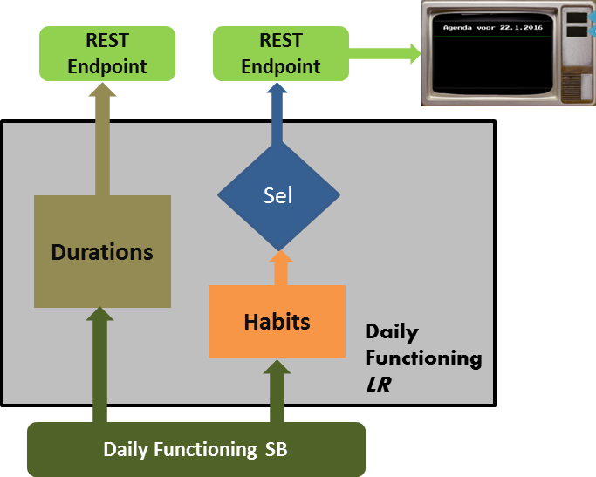

Figure 16: *Block diagram of Daily Functioning LR.*

The **Duration** branch is a simple algorithm which collects all events for a monitoring period of 4 weeks. Using these events, a duration of each event is calculated for that period. For the set of duration per event, the staistical median value is calculated. This value representes the duration of that activity for the selected period of 4 weeks. The median value is preffered as opposite to the mean value in order to avoid outliers which can introduce significant bias. This calculation of the averages is done only once in a day (at the end of the day). The monitoring period is tunable and can be changed. The repetition of some of the daily functionings is more important than their duraiotn, e.g. showering. Thus, this branch provides reasoning upon repetiion of functionings as well. The table below shows the types of activites and the performed reasoning (see Table 27).

Table 27: Overview of activity types and performed reasoning actions.

|  |  |  |
| --- | --- | --- |
| **Activity** | **Estimate** | **Reasoning** |
| Entertaining | Mean value | *Abnormal if more than 3 hour per day* |
| Showering | Median value | *Abnormal if less than two times a week* |
| Outdoors | Median value | *Abnormal if less than two times a week* |
| Socializing | Median value | *Abnormal if less than two times a week* |
| Sleeping | Mean value | *Abnormal if less than 7 hour per day (this reasoning is done here for complenteness and more accureate reasoning is done by the sleep reasoner)* |

Each of the reasoning outputs is presented as normal or abnormal. This is used as a “seed” by the *wellbeing reasoner* based on which it controls the frequency and duration of the wellbeing ads shown to the user. All of the reasoning threshold can be re-tuned if needed.

The second branch of reasoning is the **habits** branch which involves more intelligent computing in the process. This branch is using the information form the service brick to build the habits of the user. In the same manner, data for a monitoring period of 4 weeks is selected. It should be noted that the length of the monitoring period is a compromise between accuracy (larger interval) and responsiveness (smaller interval). The primary assumption is that the habits are repetative activities where the start of each activitie is within certain time frame. Another assumption is that activity can be repeated in the course of the week. For example, activity can be repeated every Monday at 4 o’clock and this is assumed to be habit for Monday. The same activity can be repeated Tuesday at the sime time and this is habbit for Tuesday, but is not related to the one on Monday. This way all habbits are build for a particular day of the week and are independent of the date or the day of the month.

Once the habbits are built, there is a further filtering based on user’s preferences for which of the habbits wants to be informed. This filtration is done by the block selection block “Sel” marked in Figure 10. The preferences are setup in the reasoner configuration.

### Reasoner output

The reasoner provide two endpoints each one serving one of the reasoning branches. Both endpoints are of type GET and returns data only upon request. The returned data is in JSON format. The table below shows the parameters returned by the method **duration**.

|  |  |
| --- | --- |
| **duration** | |
| entertaining | “normal”, “abnormal” |
| showering | “normal”, “abnormal” |
| outdoors | “normal”, “abnormal” |
| socializing | “normal”, “abnormal” |
| sleeping | “normal”, “abnormal” |

Retrieving the habits is done by the method **habits** and its response is a list of the estimated habits. If the list is empty means that the reasoner was not able to infer any habits. The parameters for each habit are described in the table below.

|  |  |
| --- | --- |
| **Habits** | |
| habit | ”entertaining”, ”showering” etc (each one of the available funcionings delivered by the Daily Functioningservice brick) |
| dayofweek | “sunday”, “monday” etc. |
| timeofday | HH:mm:ss.SSSZ, local time zone of the user when the habit is done |

Both methods don’t have input parameters and the estimated values delivered by each are done based on an optimal time interval determined in the experiments. The output provided by the lifestyle reasoner can be used by the Personal Daily Support Service or a dedicated service that can provide well-timed wellbeing advertisements.

### References

**(Burns, 2002)** Burns A., Zaudig M., Mild cognitive impairment in older people, Rapid Review, Lancet 2002.

**(Gauthier et al., 2006)** Gauthier S., et al., Mild cognitive impairment, Lancet 2006.

**(Rogers et al, 2008)** Sean L. Rogers, Rhonda B. Friedman, The underlying mechanisms of semantic memory loss in Alzheimer's disease and semantic dementia, Neuropsychologia, Volume 46, Issue 1, 2008, Pages 12-21, ISSN 0028-3932.

**(Zarit et al., 1982)** Zarit, Steven H., Judy M. Zarit, and Karen E. Reever. "Memory training for severe memory loss: Effects on senile dementia patients and their families." Gerontologist (1982): 373-377.

**(AP Association, 1987)** AP Association, “Diagnostic and statistical manual of mental disorders”, American Psychiatric Association, Washington, DC (1987).

## Home Environment Lifestyle Reasoner

### Background

Many behavioral and physiological processes in humans oscillate with a 24 hour period, including sleep–wake, activity, body temperature, blood pressure and hormone secretion. The systemic circadian rhythms in humans are maintained via the function of the body’s master clock in the brain **(Musiek, 2015)**, which receives input from the retina and synchronizes the processes in the organs to the light-dark day cycle. On a cellular level, circadian rhythms are generated by the core circadian clock. This clock is present in most cells in the body, including neurons. The core circadian clock regulates the circadian expression of thousands of genes in a tissue-specific manner, and is a major regulator of cellular metabolism, stress response, and many other functions.

Numerous studies over the past 30 years have described a wide variety of circadian and sleep-wake cycle aberrations which occur in aging and neurodegenerative diseases such as Alzheimer disease (AD), Parkinson disease (PD), Huntington disease (HD). Behavioral and psychological symptoms, such as nocturnal restlessness/agitation and wandering, are seen in 90% of patients with dementia at some point in their life **(Shin et al., 2014)**. Agitation, which means the person is restless or worried, can cause pacing, sleeplessness, or aggression. People with dementia often sleep for large parts of the day and are awake for about 40% of the night. Being awake at night increases the likelihood that they will get out of bed and fall in the dark. People with dementia are three times more likely to fall than other older adults. Sleep problems also lead to more problems with memory, as shown by worse scores on tests of recognition and recall **(Alzheimer, 2013)**. Moreover, nighttime waking and poor sleep are a leading cause for patients to enter long-term care facilities.

Currently, there is no known cure for these types of diseases. Although it is possible to slow the worsening of some of the symptoms, nothing can completely stop the disease’s process. One of the recommendations of professionals is that caregivers try to manage patients’ symptoms, prevent triggers that upset the person, and arrange the environment to ensure his or her safety.  The foundation of non-pharmacologic management is recognizing that the person with dementia is no longer able to adapt, and that instead the living environment must be adapted to the person’s specific needs. Such adaptation can be high-intensity lighting in home or care facility environment **(Hanford & Figueiro, 2013)**. It can play an important role in managing these behavioral and psychological symptoms by impacting both the visual and the circadian system with non-pharmacological intervention **(Torrington & Tregenza, 2007)**. The best-known benefits of light are visual, i.e., being able to see, and the prevention of falls. Moreover, light plays a role in regulating important biochemical processes, immunologic mechanisms, and neuroendocrine control (for instance, melatonin and cortisol), via the skin and via the eye **(Webb, 2006)**. Exposure to light is the most important stimulus for synchronizing the biological clock **(Konis, 2014)**, elevating core body temperature, and enhancing alertness**(van Hoof, 2010)**.

In people with Alzheimer’s, degenerative changes in the brain appear to be a biological basis for circadian disturbances, which might be reversed by stimulation of the brain by light. In institutional settings, these problems concerning the proper functioning of the circadian rhythmicity deteriorate and in combination with behavioral problems pose stress on professional careers, other residents and the family members. In older adults, light levels needed for the functioning of the brain are significantly higher than those required for proper vision, due to opacification and yellowing of the lens of the eyes. In practice **(van Hoof et al., 2008)**, many older adults are not exposed to illuminance levels that are sufficiently high, due to poorly lit homes (up to 400 lx), and the short periods of time spent outdoors. This forms a great contrast with the horizontal illuminances found outdoors that can reach between 10,000 and 100,000 lx during daytime.

Currently many researchers are proving that bright light resulted in a modest improvement in dementia symptoms. Specifically, the use of bright daytime lighting:

* Reduced cognitive decline on a mental status exam by a relative 5%.
* Cut depression symptoms by a relative 19%.
* Calmed slow increases in functional limitations by slightly more than half (53%).

The simple measure of increasing the illumination level in group care facilities decreases the symptoms of disturbed cognition, mood, behavior, functional disabilities, and sleeping disorders **(Figueiro et al., 2014)**. Hence by regulating the circadian rhythm in elderly using light intensity control utilizing a short-wave white light during the day may be a low cost, no harm way to help Alzheimer’s and related dementias patients get more sleep. The research tests **(Murphy, 2015)** suggest that people with Alzheimer’s can sleep better; they may be able to feel and function better and perhaps even slow the progression of their disease. And while there’s no research yet to support this: It’s possible that improving sleep in people who haven’t yet shown any signs of developing Alzheimer’s might prevent the disease or delay its onset. The sleep problems that people with dementia have may predate and even contribute to the development of the disease. At least one study found that poor sleep was linked to the presence of a molecule that leads to the formation of plaque in the brain—the same kind of plaque found in people with Alzheimer’s disease.

### Implementation

This reasoner is implemented in JAVA following the common framework for reasoners adopted in eWALL. Its algorithmic operation is presented in the flowchart in Figure 21. This reasoner aims at maintaining room illuminance to the levels depicted in Figure 22.

The Home Environment Lifestyle Reasoner is started once each week using the scheduling mechanisms provided by SpringBoot framework. It requests illuminance data for the past 7 days from the Environment service brick. Upon receiving the data, the reasoner checks its validity and if it finds valid data for any hour in the past 7 days, it inserts this data into a two-dimensional array. It counts how many valid records it received for a particular hour of the day and averages the illuminance for every hour (0-24) over the past 7 days. Based on the results, it always schedules a general statement notification and, if the illuminance in a particular hour was lower than a certain threshold (depicted in Figure 22), a morning action notification for this hour is scheduled. Finally, the reasoner inserts these notifications in the database, or, if there are already records for these notifications, updates these records.



Figure 21: Flowchart of the Home Environment Lifestyle Reasoner operation.

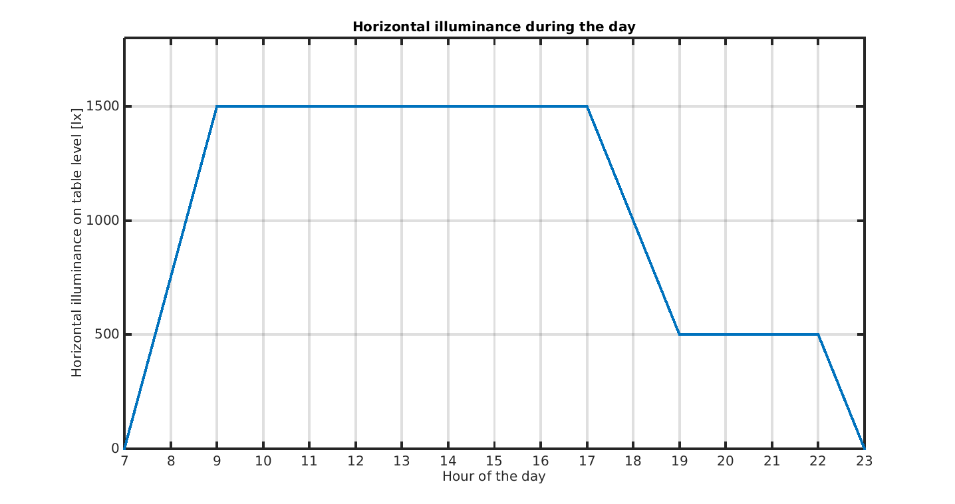

Figure 22: Illuminance levels maintained by the Home Environment Lifestyle Reasoner.

The illuminance levels depicted in Figure 22 were based on the work of **(van Hoof et al., 2013)**. In their work they investigated how illuminance levels reflect the condition of hospotalised patients with MCI. Their investigation found out that the light levels in special facilities were very low and they proposed to add controled light in the common rooms. They also proposed to control the color temperature of the light. In our case we assume that the living room is with better light so we removed the dip in the illuminace around noon which was proposed by **(van Hoof et al., 2013)**. Although we can utilize the Philips Hue lamp, which was integrated in eWALL, there is need of more than one lamp in order to achieve greater illuminance levels. This can increase the cost per installation, and was postponed for further research.

### Reasoner output

The reasoner interacts with the user via two channels, first one are the notifications while the second one is the light actuators. The notifications are in the form of general recommendation and suggestion for action. They are described in the following table.

|  |  |  |
| --- | --- | --- |
| Notification description | Notification example | Response |
| a general statement about a good in house lights, sent two times a week | *Hello Bob! According science, bright lights in the house can improve your night sleep and heart beats* | *OK* |
| a suggestion for action in the morning, sent two times a week | *Hello Bob! Bright light in the morning can help you sleep better at night. eWALL suggests you to increase the light now since it is too low. Would you eWALL to increase it for you?* | *Yes* or *No* The first choice increases the intensity of Philips Hue lamp located in the living room. |
|  |  |

If the user selected automatic control from the personalized settings, then the reasoner will try to follow the suggested light pattern by controlling the Philips Hue lamp actuator. This will not stop the notifications if the light pattern is not accomplished.

### References

**(Musiek, 2015)** E. S. Musiek, Circadian clock disruption in neurodegenerative diseases: cause and effect?, Front. Pharmacol., 27 February 2015 |<http://dx.doi.org/10.3389/fphar.2015.00029>

**(Shin et al., 2014)** Shin HY, Han HJ, Shin DJ, Park HM, Lee YB, Park KH. Sleep problems associated with behavioral and psychological symptoms as well as cognitive functions in Alzheimer’s disease. J Clin Neurol. 2014 July; 10(3): 203-9.

**(Alzheimer, 2013)** Alzheimer’s Association. 2013 Alzheimer’s disease facts and figures. Alzheimers Dement. 2013; March 9(2): 208-45.

**(Hanford & Figueiro, 2013)** N. Hanford, M. Figueiro, Light Therapy and Alzheimer’s disease and Related Dementia: Past, Present, and Future, J Alzheimers Dis. 2013 Jan 1; 33(4): 913–922. doi:  10.3233/JAD-2012-121645

**(Torrington & Tregenza, 2007)** Torrington JM, Tregenza PR. Lighting for people with dementia. Lighting Research and Technology 2007; 39(1): 81–97.

**(Webb, 2006)** Webb AR. Considerations for lighting in the built environment: nonvisual effects of light. Energy and Buildings 2006; 38(7): 721–7.

**(Konis, 2014)** K. D. Konis, Daylight & Dementia care: Daylight design performance criteria for dementia care facilities, report National professional conference, “The Value of Design: Design & Health”, hosted in Washington, D.C., April 22-24, 2014, by the American Institute of Architects.

**(van Hoof, 2010)** J. van Hoof, Ageing-in-place: The integrated design of housing facilities for people with dementia, dissertation by Hogeschool Utrecht University of Applied Sciences, 2010.

**(van Hoof et al., 2008)** J. van Hoof, M.P.J. Aarts, C.G. Rense, A.M.C. Schoutens, Ambient bright light in dementia: Effects on behaviour and circadian rhythmicity, Building and Environment (2008), doi:10.1016/j.buildenv.2008.02.005

**(Figueiro et al., 2014)** Figueiro MG, Plitnick BA, Lok A, Jones GE, Higgins P, Hornick TR, Rea MS. Tailored lighting intervention improves measures of sleep, depression, and agitation in persons with Alzheimer’s disease and related dementia living in long-term care facilities. Clin Interv Aging. 2014; 9: 1527–1537.

**(Murphy, 2015)** A. Murphy, How light can improve life for people with Alzheimer’s disease and related dementias, The national center for health research online article, 2015

**(van Hoof et al., 2013)** J. van Hoof, Eveline J . M . Wouters, B. Schräder, H. Weffers, M. Aarts, M. Aries, and A. Westerlaken, Medical Applications of Artificial Intelligence Intelligent Light Therapy for Older Adults: Ambient Assisted Living, Medical Applications of Artificial Intelligence (2013), doi: 10.1201/b15618-22

## Calendar Lifestyle Reasoner

### Background

A healthy lifestyle is not only defined by values of physiological parameters but also by the emotional, psychological and social well-being in daily life. It is within the objectives of eWALL to support active ageing and promote well-being in the daily lives of the older users. The *Calendar Lifestyle Reasoner* is aimed to target the promotion of an active lifestyle in terms of participation in social- and outdoor activities. Therefore, the added-value of the *Calendar Lifestyle Reasoner* should be shared by the three target groups, as its role is not condition specific but, instead, it concerns the promotion of well-being of all older adults.

Loneliness is a major cause of depression among older adults **(Singh and Misra, 2009)**. Fear of stigma associated with growing old, functional decline and loss of beloved ones, often lead to social isolation **(Almeida et al., 2015)**, **(Hoogendijk et al., 2016)**, **(Mulasso et al., 2016)**.

Participation in social activities is linked to quality-of-life as it has been associated with higher experience of general wellbeing **(Adams et al., 2011)** and positive emotions **(Gagliardi et al., 2010)**, **(Hillerås et al., 1998)**, **(Oerlemans et al., 2011)**, **(Onishi et al., 2006)**. The eWALL supports elderly users in the maintaining or achieving a social active lifestyle by keeping track of the social activities performed by the user and suggesting new activities whenever the social activity of the user is below what is desired.

Older adults tend to spend most of their time within the home environment. One reason is the intention for social isolation mentioned above. Other reason is simply the tedious of not knowing what to do. Along with social activities, outdoor activities are associated with higher positive emotions and better quality-of-life **(Gagliardi et al., 2010)**, **(Kaspar et al., 2015)**, **(White and Dolan, 2009)** (Gagliardi et al. 2010; Kaspar et al. 2015; White and Dolan 2009). Therefore, it is also a goal of eWALL to promote a healthy outdoors life.

Bearing in mind that the needs for social activity are highly personal, ideally, from the mood and personality tests, the eWALL should be able to estimate how social the user is and how important it is for him to have an active social life. Based on that, eWALL should automatically adapt the thresholds for the number of social activities per week. Although this hidden intelligence is very important in eWALL, the user should also be able to directly express their will to be motivated for more social activity.

In the *Calendar Application*, the users tag each activity as being performed alone or with someone else. The same happens with the location of each activity. When scheduling a new activity, the user must select if this activity will be performed at home or outdoors (*My Calendar Application*). Therefore, eWALL can keep track of the social companions and location of the activities scheduled.

The latter is clearly highly dependent on how complete the data in the agenda is. If the user does not schedule everything in the eWALL agenda, the information provided by the reasoner will not be accurate. To try to overcome this issue, users will be reminded to complete their agenda. Also, before suggesting a new activity, eWALL will always ask if the reasoning is correct or whether the user did not mention certain activities.

### Implementation Scenarios

The Calendar Lifestyle Reasoner is a conceptual design for future improvement of the eWALL platform. As the eWALL project large scale demonstration does not allow for significant changes in the software and features after the start of the trial, the implementation of the calendar lifestyle reasoner is deferred until the continuation of the project as a commercial activity, after the project’s lifespan.

The following sections describe typical usage scenarios in which the potential application of the calendar lifestyle reasoner is described, and high-level implementation requirements are defined.

#### Stimulating participation in social activities

Henry hasn’t registered/planned any social activity during the last week. The eWALL makes Henry aware of this fact and asks if he would like to schedule a new activity. Henry can ignore or plan a new activity. Henry decides to schedule a new activity and eWALL opens the Calendar app.

*Requirements*:

* The *Calendar Lifestyle Reasoner* keeps track of the number of social activities scheduled per day.
* (Personal Daily Support Service) If there was no social activity in the last days (*to be defined*) and there is no social activity planned for today or tomorrow, eWALL should send a notification to the user asking to open the calendar app to schedule an activity. The user can ignore or agree on the notification.
* (Personal Daily Support Service) From this notification the user can decide to open the calendar app.

#### Stimulating participation in outdoor activities

Henry hasn’t left the house for two days and he does not have any activities planned outdoors for today or tomorrow. The eWALL asks Henry if he would like to schedule a new outdoors activity. Henry decides to ignore the notification as he will be leaving the house later that day.

*Requirements*:

* The *Calendar Lifestyle Reasoner* keeps track of the number of outdoor activities scheduled per day.
* (Personal Daily Support Service) If there was no outdoor activity in the last days (*to be defined*) and there is no outdoor activity planned for today or tomorrow, eWALL sends a notification to the user asking to open the calendar app to schedule an activity. The user can ignore or agree on the notification.
* (Personal Daily Support Service) From this notification the user can decide to ignore or to open the calendar app.
* (Caregiver Application) If there was no outdoor activity in the last number of days defined by the caregiver, and there is no outdoor activity planned for today or tomorrow, the caregiver must be notified.

### References

**(Adams et al., 2011)** Adams, K. B., Leibbrandt, Sy., & Moon, H. (2011). A critical review of the literature on social and leisure activity and wellbeing in later life. Ageing and Society, 31(04), 683–712. http://doi.org/10.1017/S0144686X10001091

**(Almeida et al., 2015)** Almeida, O. P., Hankey, G. J., Yeap, B. B., Golledge, J., Norman, P. E., & Flicker, L. (2015). Depression, frailty, and all-cause mortality: a cohort study of men older than 75 years. Journal of the American Medical Directors Association, 16(4), 296–300. http://doi.org/10.1016/j.jamda.2014.10.023

**(Gagliardi et al., 2010)** Gagliardi, C., Marcellini, F., Papa, R., Giuli, C., & Mollenkopf, H. (2010). Associations of personal and mobility resources with subjective well-being among older adults in Italy and Germany. Archives of Gerontology and Geriatrics, 50(1), 42–47. http://doi.org/10.1016/j.archger.2009.01.007

**(Hillerås et al., 1998)** Hillerås, P. K., Jorm, A. F., Herlitz, A., & Winblad, B. (1998). Negative and positive affect among the very old: A survey on a sample age 90 years or older. Research on Aging, 20(5), 593–610. http://doi.org/10.1177/0164027598205003

**(Hoogendijk et al., 2016)** Hoogendijk, E. O., Suanet, B., Dent, E., Deeg, D. J. H., & Aartsen, M. J. (2016). Adverse effects of frailty on social functioning in older adults: Results from the Longitudinal Aging Study Amsterdam. Maturitas, 83, 45–50. http://doi.org/10.1016/j.maturitas.2015.09.002

**(Kaspar et al., 2015)** Kaspar, R., Oswald, F., Wahl, H.-W., Voss, E., & Wettstein, M. (2015). Daily mood and out-of-home mobility in older adults: Does cognitive impairment matter? Journal of Applied Gerontology, 34(1), 26–47. http://doi.org/10.1177/0733464812466290

**(Mulasso et al., 2016)** Mulasso, A., Roppolo, M., Giannotta, F., & Rabaglietti, E. (2016). Associations of frailty and psychosocial factors with autonomy in daily activities: a cross-sectional study in Italian community-dwelling older adults. Clinical Interventions in Aging, 11, 37–45. http://doi.org/10.2147/CIA.S95162

**(Oerlemans et al., 2011)** Oerlemans, W. G. M., Bakker, A. B., & Veenhoven, R. (2011). Finding the Key to Happy Aging : A Day Reconstruction Study of Happiness, 66, 665–674. http://doi.org/10.1093/geronb/gbr040.

**(Onishi et al., 2006)** Onishi, J., Masuda, Y., Suzuki, Y., Gotoh, T., Kawamura, T., & Iguchi, A. (2006). The pleasurable recreational activities among community-dwelling older adults. Archives of Gerontology and Geriatrics, 43(2), 147–55. http://doi.org/10.1016/j.archger.2005.10.003

**(Singh and Misra, 2009)** Singh, A., & Misra, N. (2009). Loneliness, depression and sociability in old age. Industrial Psychiatry Journal, 18(1), 51–5. http://doi.org/10.4103/0972-6748.57861

**(White and Dolan, 2009)** White, M. P., & Dolan, P. (2009). Accounting for the richness of daily activities. Psychological Science, 20(8), 1000–8. http://doi.org/10.1111/j.1467-9280.2009.02392.x

## eWALL Interaction Lifestyle Reasoner

### Background

The goal of this reasoner is to identify the actual usage patterns of the user to allow gentle reminders of eWALL functionalities that support important activities. In other words, the reasoner will assist the notification component (Personal Daily Support Service) to motivate the user to take full advantage of the system, thus contributing to user engagement. User engagement is a very important aspect of user experience and refers to the intention of the user to use an application longer and repeatedly **(Lalmas et al., 2014)**. The Interaction Lifestyle Reasoner will account for user engagement by measuring frequency and duration of use as well as providing an administrative overview of the most and the least popular apps.

Users can only benefit from a system such as eWALL if they use its services consistently. Event scheduling, health and physical exercise monitoring require the active interest of the user for adding input and checking the data in order to be useful for her/him and the caregivers. An empty calendar with 1-2 events will never be opened, but a calendar where all activities of the user are registered, will become an indispensable tool. Habit formation, such as the common habit of checking the smartphone, can lead to more extensive and consistent use of the system **(Oulasvirta et al., 2012)**. Once the habit is installed and the user is interacting with the system, the Personal Daily Support Service will be aware that the interaction habit has been established through the Interaction Lifestyle Reasoner, and will subsequently reduce the number of reminders regarding the use of the system.

The role of the eWALL Interaction Lifestyle Reasoner in reminding users about the system services can be particularly fruitful, especially for MCI adults, as they are likely to forget the presence of eWALL and have decreased ability to manage technology **(Rosenberg et al., 2009)**, **(Malinowsky et al., 2010)**.

The reasoner should keep track of and provides information about the usage patterns of the users. The first objective of the Lifestyle Reasoner is thus:

|  |  |
| --- | --- |
| **Objective 1** | *The Lifestyle Reasoner should collect information regarding the use of eWALL in general well as the use of specific eWALL applications.* |

In order to provide added value to the user experience in daily use of the eWALL platform, the Lifestyle Reasoner should provide input to the Personal Daily Support Service regarding the use of the platform, as defined in the following two objectives:

|  |  |
| --- | --- |
| **Objective 2** | *The Lifestyle Reasoner provides information regarding the frequency of use of eWALL in general.* |
| **Objective 3** | *The Lifestyle Reasoner provides information regarding the frequency of use of specific eWALL applications.* |

When considering eWALL as a product, the eWALL Interaction Lifestyle Reasoner has the potential of providing additional detailed information that can provide useful input to new feature development or updates to the platform. The following information that can be provided by the Lifestyle Reasoner are less important to the daily use of eWALL for the primary end-user groups, but are useful in the evaluation of the product/project and later for administrators of eWALL as an exploitation company. For this functionality, the following three additional objectives are defined.

|  |  |
| --- | --- |
| **Objective 4** | *The Lifestyle Reasoner can provide information regarding the duration of interaction with eWALL in general.* |
| **Objective 5** | *The Lifestyle Reasoner can provide information regarding the duration of use of each specific eWALL application.* |
| **Objective 6** | *The Lifestyle Reasoner can provide information regarding changes in the frequency of use of eWALL, or specific eWALL applications.* |

Since development efforts are focused on the execution of a successful demonstration of the eWALL platform for the end-users, the implementation of the eWALL Interaction Lifestyle Reasoner is focused on the development of **Objective 1**, **Objective 2**, and **Objective 3**.

### Implementation

The eWALL Interaction Lifestyle Reasoner implementation focuses around a number of eWALL components. In order to limit the number of different components required for the functionality to be delivered, the *InteractionLogger & Reasoner* is a single component that takes user interaction logging events from the main screen and applications, provides the required reasoning, and provides the output to the Virtual Coach. In Figure 23, a high-level overview of all relevant components is given. The *Interaction Logger & Reasoner* is the main component for the lifestyle reasoner, and together with the *Virtual Coach* constitute the cloud components needed for this functionality. The eWALL *MainScreen* and *eWALL Apps* in Figure 23 are the client side components in which the required interaction logging is taking place.

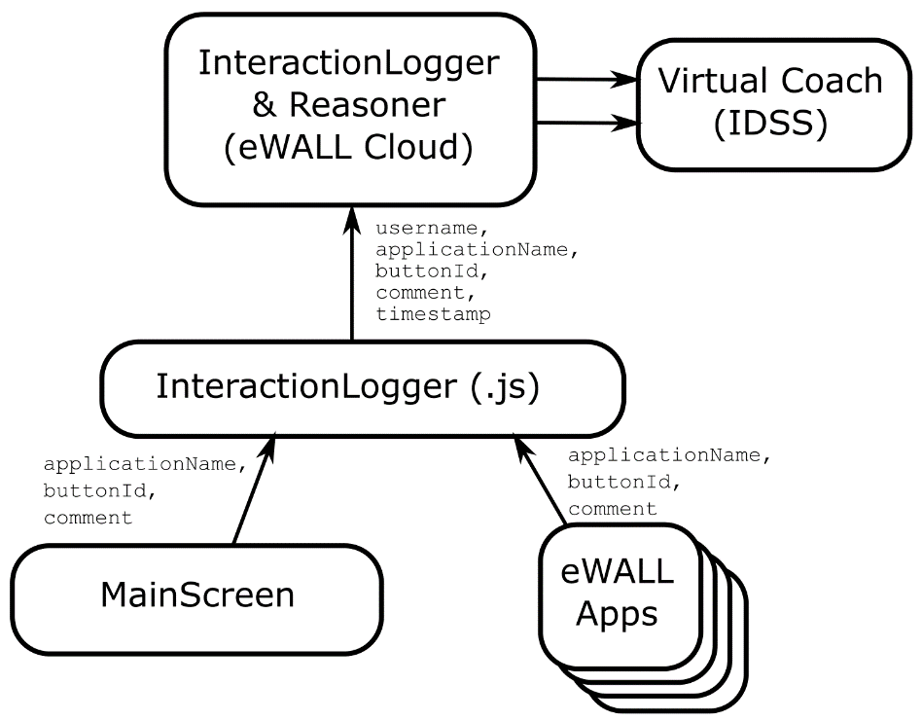

Figure 30:High level component overview showing the eWALL Interaction Lifestyle Reasoner (InteractionLogger & Reasoner) component and the related UI and IDSS components.

The newly developed component for the eWALL Interaction Lifestyle Reasoner is the user-interaction-logger. Table 28 below summarizes the general implementation details regarding this lifestyle reasoner.

Table 28: General information on the eWALL Interaction Lifestyle Reasoner implementation.

|  |  |
| --- | --- |
| **Source code** | http://serv2.radio.pub.ro/gitlab/wp4/wp4project.git  user-interaction-logger |
| **Configuration** | Environment-dependent properties are set in:  src/main/resources/user-interaction-logger-*.properties |
| **Storage** | Data is stored in database user_interaction_log_db (see properties) in MongoDB. |

#### Client Side Logging

The first objective of the eWALL Interaction Lifestyle Reasoner is to *collect information regarding the use of eWALL in general well as the use of specific eWALL applications.* In order to achieve this, the following client-side functionality was implemented:

In the main screen, the user interface (UI) interaction logger component is present in the form of a JavaScript library which outputs two types of commands (see Figure 23: InteractionLogger (.js)):

* logging user touch interaction events: the events are associated with the user touching the main screen icons, or other user operations with the interface.
* logging user proximity interaction events: the events which are determined by the user’s presence within the eWALL environment (i.e. switching between passive and active mode).

The following data are recorded for a touch interaction event:

* **userId** = [string] the id of the user currently performing interaction, for example: “bob”.
* **applicationName** = [string] the name of the application which is currently running. When no application is running this field is set to “mainscreen”. When the user interacts with notifications, this field is set to “notification”.
* **buttonId** = [string] the value from the id field of the HTML element which reacts on the click event. For example, when launching the healthcare monitoring application, this field will be “healthcareMonitor”. This value is the same as the platform identification for the application which corresponds to the tocuhed icon/button.
* **comment** = [string] (optional) additional text which can carry specific parameters in a text format.
* **timestamp** = [string] the current timestamp in ISO-8601 format: YYYY-MM-DDTHH:mm:ss.sssZ.

The following data are recorded for a proximity event (switching active/passive mode):

* **userId** = [string] the id of the user currently performing interaction, for example: “bob”.
* **screenState** = [string] either “active” or “passive”.
* **comment** = [string] (optional) additional information, such as distance in centimeters from the screen, for example: “distance: 150”.
* **timestamp** = [string] the current timestamp in ISO-8601 format: YYYY-MM-DDTHH:mm:ss.sssZ.

The library is referred in the index.html as an additional script:

|  |
| --- |
| <script src="lib/userInteractionLogger.js"></script> |

The JavaScript methods are reachable throughout the main screen and all applications. Each method call results in a call to the InteractionLogger & Reasoner cloud component (see Figure 1) where data is stored and processed.

#### Cloud-based logging

The UserInteraction cloud component has a single entry point for collecting data. User interaction events are logged by the client-side component described above and call the /logInteraction end-point of the reasoner (see Code Snippet 1).

|  |
| --- |
| logInteraction  Paramaters  userid (required) – String  applicationName (required) – String  buttonId (required) – String  comment – String  timestamp (required) - String |

Code Snippet 1: logInteraction end-point of the eWALL Interaction Logger & Reasoner

User Interaction log events are stored in a Mongo Database called user_interaction_log_db in a number of separate tables. For each user a separate table is generated titled userinteractionlog_HEXKEY where ”HEXKEY” is an 8 digit hexadecimal user specific key. See Table 27 for the specification of the MongoDB table.

Table 29: Description of ”userinteractionlog_HEXKEY” MongoDB object for the eWALL Interaction Lifestyle Reasoner.

|  |  |
| --- | --- |
| **userinteractionlog_HEXKEY** | |
| id | Unique database related identifier. |
| applicationName | The name of the application that generated the logging event. |
| buttonId | The name of the specific UI element that generated the logging event. |
| comment | Free comment associated with the logging event. |
| dateString | The date on which the event occurred as a DD-MM-YYYY String. |
| tzTime | The timestamp of the event including timezone. |
| userid | The user identifier. |
| utcTime | The unix epoch time. |

For each new user that performs interactions with the eWALL platform a separate userinteractionlog table is created, and a hexkey generated. The mappings of usernames to these hexkeys are stored in the userkeys table (see Table 30).

Table 30: Description of the “userkeys” MongoDB object for the eWALL Interaction Lifestyle Reasoner.

|  |  |
| --- | --- |
| **userkeys** | |
| id | Unique database related identifier. |
| key | The 8-digit hexkeys used to identify specific userinteractionlog tables. |
| user | The user identifier. |

Additional processing is performed by the Interaction Lifestyle Reasoner to optimize the data output. At the beginning of each day, daily interaction events are summarized for each individual user and user/date entries are stored in the uil_daily_interactions table (see Table 31).

Table 31: Description of the “uil_daily_interactions” MongoDB object for the eWALL Interaction Lifestyle Reasoner.

|  |  |
| --- | --- |
| **uil_daily_interactions** | |
| id | Unique database related identifier. |
| day | The day of the month as int value. |
| month | The month of the year as int value. |
| year | The year as int value. |
| username | The user identifier. |
| interactions | The total number of interactions on this day, for this user as int value. |

#### Interaction retrieval end-points

In order to provide data to eWALL components that make use of the Interaction LR component’s data, the module provides a large number of simple, fast and efficient data retrieval end-points. The end-points provided by the LR are listed below (Table 32).

Table 32: List of data retrieval end-points for the eWALL Interaction Lifestyle Reasoner.

|  |  |
| --- | --- |
| **User Interaction Logger & Reasoner Data End-Points** | |
| /interactionCount | Get the total number of eWALL interactions for the given **username** up to and including the given **date.** |
| /interactionCountCalendarApplication | Get the total number of eWALL interactions with the Calendar application for the given **username** up to and including the given **date.** |
| /interactionCountCognitiveExerciseApplication | Get the total number of eWALL interactions with the Cognitive Games application for the given **username** up to and including the given **date.** |
| /interactionCountDomoticsApplication | Get the total number of eWALL interactions with the Domotics application for the given **username** up to and including the given **date.** |
| /interactionCountFallPreventionApplication | Get the total number of eWALL interactions with the Fall Prevention application for the given **username** up to and including the given **date.** |
| /interactionCountHelpApplication | Get the total number of eWALL interactions with the Help application for the given **username** up to and including the given **date.** |
| /interactionCountMainScreen | Get the total number of eWALL interactions with the main screen for the given **username** up to and including the given **date.** |
| /interactionCountMyActivityApplication | Get the total number of eWALL interactions with the My Activity application for the given **username** up to and including the given **date.** |
| /interactionCountMyDailyLifeApplication | Get the total number of eWALL interactions with the My Daily Life application for the given **username** up to and including the given **date.** |
| /interactionCountMyHealthApplication | Get the total number of eWALL interactions with the My Health application for the given **username** up to and including the given **date.** |
| /interactionCountRewardApplication | Get the total number of eWALL interactions with the Rewards application for the given **username** up to and including the given **date.** |
| /interactionCountSleepApplication | Get the total number of eWALL interactions with the My Sleep application for the given **username** up to and including the given **date.** |
| /interactionCountVideoExerciseApplication | Get the total number of eWALL interactions with the Video Exercise application for the given **username** up to and including the given **date.** |
| /lastInteraction | Get the date and time of the last interaction for the given **username**. |
| /lastInteractionCalendarApplication | Get the date and time of the last interaction with the Calendar application for the given **username**. |
| /lastInteractionCognitiveExerciseApplication | Get the date and time of the last interaction with the Cognitive Exercise application for the given **username**. |
| /lastInteractionDomoticsApplication | Get the date and time of the last interaction with the Domotics application for the given **username**. |
| /lastInteractionFallPreventionApplication | Get the date and time of the last interaction with the Fall Prevention application for the given **username**. |
| /lastInteractionHelpApplication | Get the date and time of the last interaction with the Help application for the given **username**. |
| /lastInteractionMainScreen | Get the date and time of the last interaction with the main screen for the given **username**. |
| /lastInteractionMyActivityApplication | Get the date and time of the last interaction with the My Activity application for the given **username**. |
| /lastInteractionMyDailyLifeApplication | Get the date and time of the last interaction with the My Daily Life application for the given **username**. |
| /lastInteractionMyHealthApplication | Get the date and time of the last interaction with the My Health application for the given **username**. |
| /lastInteractionRewardApplication | Get the date and time of the last interaction with the Rewards application for the given **username**. |
| /lastInteractionSleepApplication | Get the date and time of the last interaction with the My Sleep application for the given **username**. |
| /lastInteractionVideoExerciseApplication | Get the date and time of the last interaction with the Video Exercise application for the given **username**. |

### Reasoner output

The notifications produced by this reasoner, only show up when the frequency and the duration of use are too low or when some applications are ignored by the user. Promotion messages are designed to be generated for all the important eWALL applications. Examples of notification messages are described in the table below.

|  |  |  |
| --- | --- | --- |
| Notification description | Notification example | Response |
| a general statement about usage, followed by a question to the user, plus audio signal | *Hello Henry! Lately you don’t use eWALL so much. Is everything all right?* | *I’m alright or I’m not feeling well (+textbox)*. The user is then asked if s/he wants to communicate what s/he wrote with the caregivers. |
| a promotion message about important applications that are ignored by the user, plus audio signal | *Hello Henry! Just to remind you, eWALL can support you in monitoring your health. Would you like to measure your heart rate now?* | *Yes* or *Remind me later When?* The second choice opens a drop-down menu including the options in an hour, three hours, two days, a year. |
| *Hello Henry! Just to remind you, eWALL allows you to plan all your activities in the Calendar. Would you like to plan an activity now?* | *Yes or Remind me later. When?* The second choice opens a drop-down menu including the options in an hour, three hours, two days, a year. |

The application reminders are implemented in the eWALL system used in the final demonstration trials of the project as part of the Virtual Coach (see Deliverable 4.2.3). The application reminders are implemented as Dialogues with the Virtual Coach “Robin”, as seen in Figure 24.

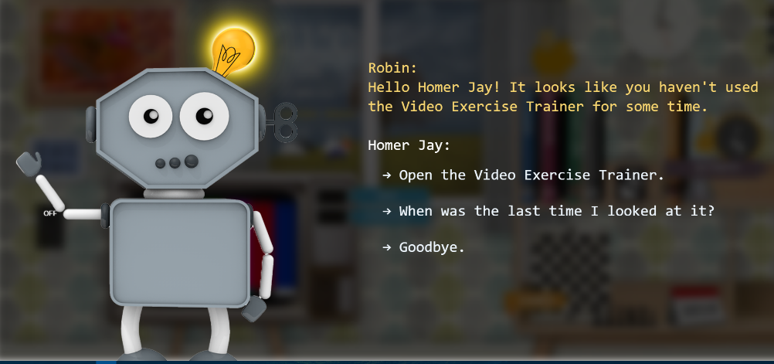

Figure 31: Screenshot of Robin the Robot providing an eWALL application reminder.

The application reminder dialogues are implemented for the 7 main eWALL applications: My Activity, the Calendar, the Cognitive Exercise games, the Domotics application, My Health, My Sleep, and the Video Exercise trainer. An example of a fully configured dialogue is given in Code Snippet 2.

|  |
| --- |
| // --------------------  // --- "Hello [firstName]! It looks like you haven't used the Video Exercise Trainer for some time."  // --- o "Open the Video Exercise Trainer."  // --- o "When was the last time I looked at it?"  // --- o "Goodbye."  // --------------------  step {  stepId "Initial"  statement "Hello [firstName]! It looks like you haven't used the Video Exercise Trainer for some time."    basicReply {  replyId "A"  statement "Open the Video Exercise Trainer."  action {  actionType "openApplication"  parameter "Physical Trainer"  }  }    basicReply {  replyId "B"  statement "When was the last time I looked at it?"  nextStepId "LastCheckedTime"  }    basicReply {  replyId "BYE"  statement "Goodbye."  action {  actionType "postponeReminder"  parameter "UseVideoExerciseTrainer"  parameter "24"  }  }  }  // --------------------  // --- "The last time you used the Video Exercise Trainer was [daysAgoLastVideoTrainerInteraction], at [timeLastVideoTrainerInteraction]."  // --- o "Thanks. Open the Video Exercise Trainer."  // --- o "Goodbye."  // --------------------  step {  stepId "LastCheckedTime"  statement "The last time you used the Video Exercise Trainer was [daysAgoLastVideoTrainerInteraction], at [timeLastVideoTrainerInteraction]."    basicReply {  replyId "A"  statement "Thanks. Open the Video Exercise Trainer."  action {  actionType "openApplication"  parameter "Physical Trainer"  }  }    basicReply {  replyId "BYE"  statement "Goodbye."  action {  actionType "postponeReminder"  parameter "UseVideoExerciseTrainer"  parameter "24"  }  }  } |

Code Snippet 2: Groovy file declaration of the “Use Video Exercise Application” reminder dialogue, used by Robin the Virtual Coach.

### References

**(Malinowsky et al., 2010)** Malinowsky, C., Almkvist, O., Kottorp, A., & Nygård, L. (2010). Ability to manage everyday technology: a comparison of persons with dementia or mild cognitive impairment and older adults without cognitive impairment. Disability and rehabilitation: Assistive technology, 5(6), 462-469.

**(Lalmas et al., 2014)** Lalmas, M., O'Brien, H., & Yom-Tov, E. (2014). Measuring user engagement. Synthesis Lectures on Information Concepts, Retrieval, and Services, 6(4), 1-132.

**(Oulasvirta et al., 2012)** Oulasvirta, A., Rattenbury, T., Ma, L., & Raita, E. (2012). Habits make smartphone use more pervasive. Personal and Ubiquitous Computing, 16(1), 105-114.

**(Rosenberg et al., 2009)** Rosenberg, L., Kottorp, A., Winblad, B., & Nygård, L. (2009). Perceived difficulty in everyday technology use among older adults with or without cognitive deficits. Scandinavian Journal of Occupational Therapy, 16(4), 216-226.

# Wellbeing Advertisement Reasoner

## Background

In order to provide notifications to older adults regarding eating, drinking, showering, going for a walk, etc, we created a concept that we name „the well-being ads“. These are graphic advertisements of different well-being activities that are shown for a little while on the screen with impressive graphics and motivational scope. Since eWALL is of quite impressive dimensions, the well-being ads make eWALL appear like user‘s personal home billboard. This is a completely different paradigm from the notifications used so far for such kind of activities, which asked for feedback and/or interrupted the user in the middle of another action.

The Wellbeing Advertisement Reasoner is the intelligent component in the eWALL cloud behind the wellbeing advertisements that are shown on the TV screen of the eWALL Main Screen. These wellbeing advertisements are aimed to provide subtle reminders that aim to nudge people towards a certain behaviour. The Wellbeing Advertisement Reasoner decides which advertisement is most relevant to show to the user, based on his historical behaviour and his current context.

The wellbeing ads provide a non-intrusive way to stimulate user behaviour. They are more prominent when the eWALL main screen is in passive mode but not interacting with the user in a direct way. The core idea is that the advertisements are subtly noticed whenever the user is in the room where the eWALL is installed (e.g. the living room).

## Implementation

The Wellbeing Advertisement system consists of two parts. The Main Screen Implementation (shortly described in Section 6.2.1) requests periodically the most appropriate advertisement to show from the Reasoner Implementation (see Section 6.2.2).

### Main Screen Implementation

The wellbeing advertisements are shown on the eWALL Main Screen on the television in the living room. In the user interface’s “Active Mode” (see Figure 13), the advertisement does not have a prominent role in the screen. However, when the user steps away from the screen and the device goes into “Passive Mode”, the advertisements are clearly visible from a distance (see Figure 14).

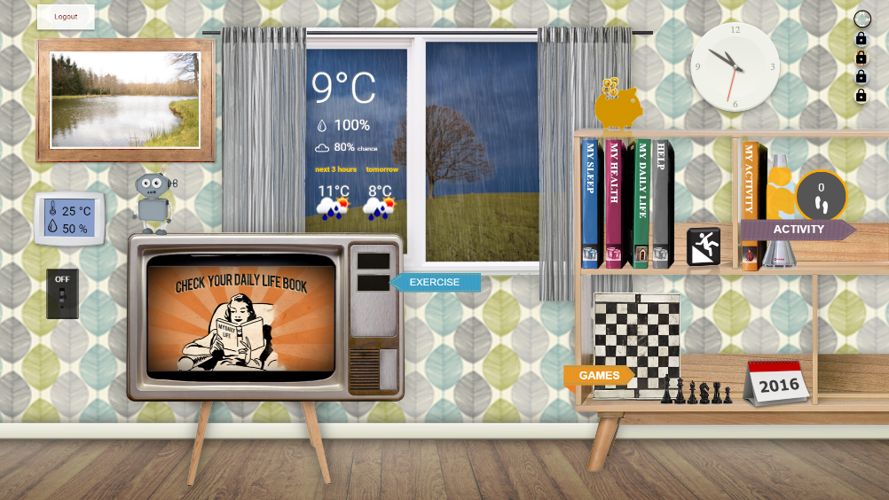

Figure 13: eWALL Main Screen user interface (active mode) showing an advertisement for looking at the Daily Life book.

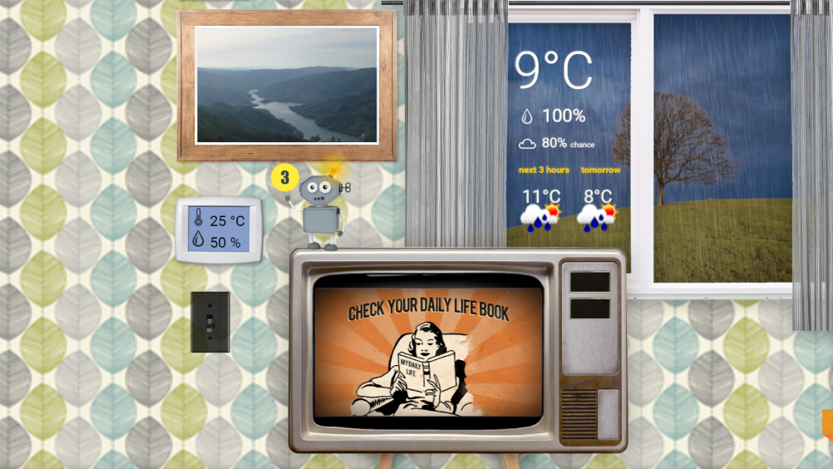

Figure 14: eWALL Main Screen user interface (passive mode), clearly highlighting the wellbeing advertisement for looking at the Daily Life book.

### Reasoner Implementation

The technical information of the Wellbeing Advertisement component can be found in Table 4.

Table 4: Component ID card for the Wellbeing Advertisement Reasoner.

|  |  |
| --- | --- |
| Artifact: idss-reasoner-wellbeing-ads | |
| Maven artefact | eu.ewall.platform.idss/idss-reasoner-wellbeing-ads |
| Git Address | http://serv2.radio.pub.ro/gitlab/wp4/wp4project/tree/stable/idss-reasoner-wellbeing-ads |
| Continuous Integration | http://ewall.radio.pub.ro/jenkins/job/wp4-release/eu.ewall.platform.idss$idss-reasoner-wellbeing-ads/ |
| Javadoc location | http://ewall.radio.pub.ro/jenkins/job/wp4-release/eu.ewall.platform.idss$idss-reasoner-wellbeing-ads/javadoc/ |
| Nexus location | http://ewall.radio.pub.ro/nexus/content/repositories/releases/eu/ewall/platform/idss/idss-reasoner-wellbeing-ads/1.0.0/ |
| Version | 1.0.0 |
| Responsible partner | ENT, RRD |

The eWALL Main Screen requests periodically from the Wellbeing Advertisement Reasoner which is the most appropriate advertisement to show from the set of 12 available advertisements. The advertisements that have been developed in the project and translated to Dutch, Italian, German and Danish are as follows:

* Go for a bike ride
* Go to sleep
* Perform video exercises
* Engage in cognitive exercise
* Don’t skip breakfast
* Listen to music
* Meet some people
* Check your activity book
* Check your sleep book
* Check your health book
* Check your daily life book
* Check your help book

The advertisements developed relate mostly to the set of eWALL applications used in the final demonstration (e.g. “Go to sleep” -> My Sleep Application, “Check your activity book” -> My Activity Application), and in some cases to general healthy behaviour (e.g. “Let’s go Cycling”). The advertisements are listed below in Figure 15 through Figure 26.

|  |  |
| --- | --- |
| Figure 15: Go for a bike ride. | Figure 16: Go to sleep. |

|  |  |
| --- | --- |
| Figure 17: Perform video exercises. | Figure 18: Engage in cognitive exercise. |

|  |  |
| --- | --- |
| Figure 19: Don't skip breakfast. | Figure 20: Listen to music. |

|  |  |
| --- | --- |
| Figure 21: Meet some people. | Figure 22: Check your activity book. |

|  |  |
| --- | --- |
| Figure 23: Check your sleep book. | Figure 24: Check your health book. |

|  |  |
| --- | --- |
| Figure 25: Check your daily life book. | Figure 26: Check your help book. |

The reasoner core logic is based on fixed decision logics which are dependent on certain conditions such as time of the day, weather, user performance etc. The decision logic is designed in a way to balance between physical activity and cognitive training (the two main pillars of eWALL functionalities). Most importantly this logic is dependent on the type of the user: MCI or COPD.

The overall implementation idea and building blocks are shown in Figure 27.

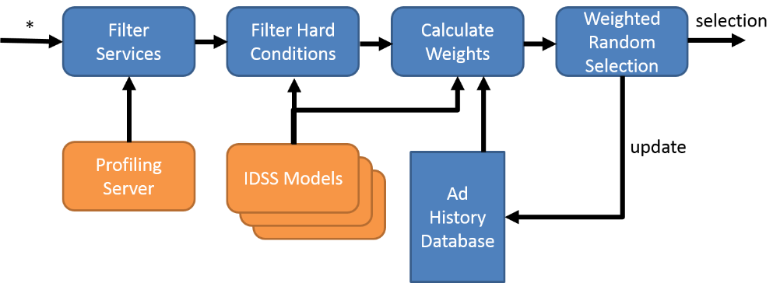

Figure 27: Wellbeing Advertisement Reasoner building blocks.

The time of appearance is adaptive and based on the results of a particular activity (i.e. cognitive training or physical training) returned by the reasoners, the time can be prolonged or shortened. Each wellbeing has its own decision logic explained below. There are blank periods, in which no add is displayed. In these periods, eWALL is displaying only the daily agenda without switching between both (see D5.3.3. for more details).

*Video Exercise*, *Bike* and *Cognitive* advertisements in the morning period are interchangeably shown depending on the outside weather conditions, user type, and the history of the adds. There are two types of decision logics depending on the user type. For the COPD patients, morning period of these adds is accenting on the physical activity, while for the MCI patients it is balancing between physical activity and cognitive training. For example, in Figure 28 is shown the decision logic for COPD patients in the morning period and in Figure 29 the decision logic, in the morning period for MCI patients.

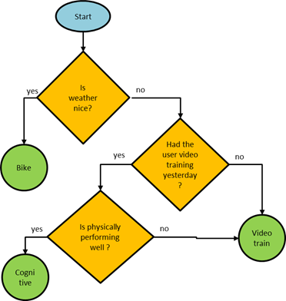

Figure 28: Decision logic, morning period for COPD patients.

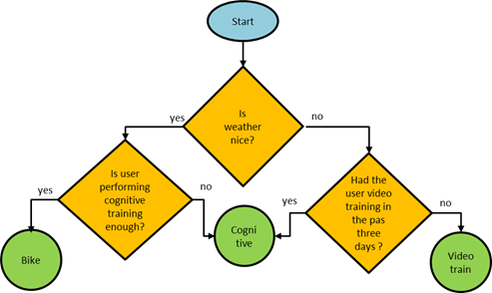

Figure 29: Decision logic, morning period for MCI patients.

On the afternoon period, both the periods of cognitive training and bike/video training ads do not overlap. Also, the bike ad is displayed only during the weekends and if the weather is nice it is stimulating the user to go for ride independently of the user’s physical or cognitive training performance. This is stimulating the user to take more outdoor activities in the weekend. Again, there are two decision logics dependent on the type of the user. Another difference from the morning period is that the cognitive training can overtake over the time of the bike/video training if certain conditions are met. For example, in Figure 30 is shown the decision logic for afternoon period for COPD patients and in Figure 31 is shown the decision logic for afternoon period for MCI patients.

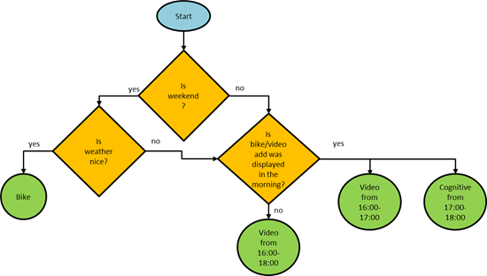

Figure 30: Decision logic, afternoon period for COPD patients.

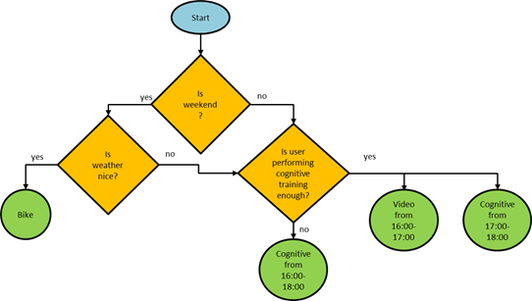

Figure 31: Decision logic, afternoon period for MCI patients.

The **music advertisement** is dependent on the user’s mood and day of the week. In Sunday, the ad is overtaking the period from 17:00 to 20:00 and is advertising the user to listen to music. This ad can extend the display period depending on the user’s mood. For example, in Figure 32 is shown the decision logic for afternoon period for COPD patients.

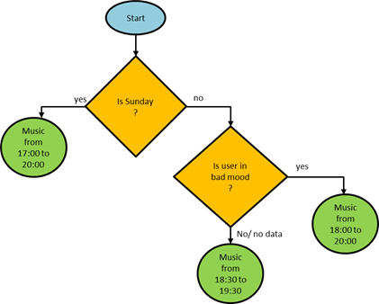

Figure 32: Decision logic, afternoon period for COPD patients.

The **sleep advertisement** is displayed every day in the basic period. The reasoner is checking if the user had a proper sleep last night and if this is not the case, the reasoned is extending the display period starting from 20:00.

# Automatic Goal-Setting

## Background

The Automatic Goal-setting IDSS reasoner (AGS-IDSSr) sets personalized goals with minor or no involvement from the healthcare professional. The goals are set based on user’s previous behavior (user’s routine) and healthcare recommendations (national guidelines or direct involvement of healthcare professional through the eWALL web portal). The goal-setting should not depend on the measure unit in use, i.e. steps, distance, calories, IMA, or ISA. Since the different activity units can be converted from one to the other, we will focus the goal-setting on a single, most understandable unit: *steps*.

The Goal Setting IDSS reasoner runs once every week and defines the goals for the upcoming week. When a new goal needs to be set, the user’s **pattern of daily physical activity** is averaged and the **average “end points”** compared to the **ultimate goal**. Days that are considered *outliers,* given the lifestyle pattern of the user (this task is performed by the Daily Physical Activity Lifestyle Reasoner in Task 5.2) are not considered in this calculation. If the average daily point is close to the ultimate goal, the new goal set corresponds to the ultimate goal. Otherwise, the new goal will be the average daily end point weighted by a **deviation allowance factor**. The implementation of the eWALL automatic goal-setting reasoner is based on the work described in **(Cabrita et al., 2014)**.

**Overview of different goal types**

For every week (Monday to Sunday), the reasoner will set a number of different goals (prioritized by implementation need):

Table 7: Possible different goal variations ordered by priority from the eWALL requirements analysis.

|  |  |  |
| --- | --- | --- |
| **Goal** | **Priority** | **Completion** |
| 7 Daily Step Goals | 1 | 100% |
| 7 Daily Step Balance Goals | 2 | 0% |
| 1 Weekly Step Goal | 3 | 0% |
| 1 Weekly Vigorous Activity Goal | 4 | 0% |
| 7 Daily Inactivity Goals (Balance and/or Daily Total) | 5 | 0% |
| 1 Weekly Inactivity Goal (Balance and/or Daily Total) | 6 | 0% |

**Goal Type: Daily Step Goals**

The goal setting of the daily step goals is performed by following the 6 steps mentioned below. The general idea is that this reasoner runs once a week (e.g. every Sunday evening). First it requests the daily physical activity lifestyle pattern. Then it defines a new goal for each category of activity (i.e. inactive, normal and active days). This means that every week, the reasoner will set a minimum one goal (in case every day is a normal day) and maximum 3 different goals (if there are active-, inactive and normal days).

***Step 1:*** *Request lifestyle pattern from WP5*. Example of data from lifestyle reasoner:

|  |  |  |  |
| --- | --- | --- | --- |
| **Weekday** | **Classification** | **Week 39** | **Week 40** |
| **Monday** | **Inactive** | **3536** | **3654** |
| **Tuesday** | **Inactive** | **3986** | **4012** |
| **Wednesday** | **Normal** | **6523** | **6652** |
| **Thursday** | **Active** | **8569** |  |
| **Friday** | **Normal** | **5986** |  |
| **Saturday** | **Active** | **9032** |  |
| **Sunday** | **Inactive** | **4736** |  |

***Step 2:*** *Calculate the average of each category that exists. Following the example above, the outcome from this step would be (Note: Not all the categories need to be present. Considering that all days can be normal, for example. This classification is made by the lifestyle reasoner):*

|  |  |
| --- | --- |
| **Inactive** | 4086 |
| ***Normal*** | 6255 |
| ***Active*** | 8800 |

***Step 3:*** *Request the ultimate goal value (in steps). Set by healthcare professional, based on international guidelines, etc.*

***Step 4:*** *Goal-setting algorithm*:

if

(averageCategory > ultimateGoal) -> goalCategory = ultimateGoal

else

(goalCategory = min(ultimateGoal, averageCategory + x.averageCategory), x ∈ [0,1])

***Step 5:*** *Rounding strategy*:

The goal for each category should be rounded up (or down) to the nearest factor of y (y being configurable). For example,. an outcome of 3972 steps should be rounded up to 4000 and an outcome of 3009 should be rounded down to 3000.

***Step 6:*** *Set the daily goal according to the correspondent category, for example:*

|  |  |  |
| --- | --- | --- |
| **Monday (2014/12/08)** | (Inactive) | 4200 |
| ***Tuesday (2014/12/09)*** | (Inactive) | 4200 |
| ***Wednesday (2014/12/10)*** | (Normal) | 6500 |
| ***Thursday (2014/12/11)*** | (Active) | 9000 |
| ***Friday (2014/12/12)*** | (Normal) | 6500 |
| ***Saturday (2014/12/13)*** | (Active) | 9000 |
| ***Sunday (2014/12/14)*** | (Inactive) | 4200 |

Thus, the output of the Goal Setting Algorithm is 7 new daily step goals, for the next 7 days (the “inactive”, ”normal”, and ”active” classifications are not part of the output).

## Implementation

The technical information of the Virtual Coach component can be found in Table 8.

Table 8: Component ID card for the Automatic Goal-Setting Reasoner.

|  |  |
| --- | --- |
| **Artifact:** idss-automatic-goal-setting | |
| **Maven artefact** | eu.ewall.platform.idss/idss-automatic-goal-setting |
| **Git Address** | http://serv2.radio.pub.ro/gitlab/wp4/wp4project/tree/stable/idss-automatic-goal-setting |
| **Continuous Integration** | http://ewall.radio.pub.ro/jenkins/job/wp4-release/eu.ewall.platform.idss$idss-automatic-goal-setting/ |
| **Javadoc location** | http://ewall.radio.pub.ro/jenkins/job/wp4-release/eu.ewall.platform.idss$idss-automatic-goal-setting/javadoc/ |
| **Nexus location** | http://ewall.radio.pub.ro/nexus/content/repositories/releases/eu/ewall/platform/idss/idss-automatic-goal-setting/1.0.0/ |
| **Version** | 1.0.0 |
| **Responsible partner** | RRD |

**Configuration**

Environment-dependent properties are set in:

src/main/resources/idss-automatic-goal-setting*.properties

Other configuration options can be specified in:

src/main/resources/eu/ewall/platform/idss/automaticgoalsetting/config.xml

**Default configuration:**

The default configuration for the Automatic Goal-Setting reasoner is given in Table 9 below.

Table 9: Default configuration for the Automatic Goal-Setting reasoner.

|  |
| --- |
| <?xml version="1.0" encoding="UTF-8"?>  <config>     <incrementFactor>0.2</incrementFactor>     <roundingFactor>100</roundingFactor>     <component class="eu.ewall.platform.idss.SpringLogger" />     <component class="eu.ewall.platform.idss.service.db.mongodb.MongoDatabaseFactory" />  </config> |

The increment- and rounding factors are explained shortly as:

* **incrementFactor**: the factor by which the average activity is increased to calculate the goal. This is the x in goalCategory = averageCategory + x.averageCategory, x∈ [0,1].
* **roundingFactor**: the reasoner will round a calculated goal to the nearest number so that goal % roundingFactor = 0.

**Storage**

Data is stored in database idss_ags_db (see properties) in MongoDB. The following three MongoDB objects are defined for the Automatic Goal-Setting reasoner (see Table 10 through Table 12).

Table 10: Definition of the "_table_metadata" MongoDB object for the Automatic Goal-Setting reasoner.

|  |
| --- |
| **_table_metadata** |
| used for possible data model upgrades |

Table 11: Definition of the "goals" MongoDB object for the Automatic Goal-Setting reasoner.

|  |  |
| --- | --- |
| **goals** | |
| user | username |
| date | yyyy-MM-dd, local timezone of the user |
| category | INACTIVE, NORMAL, ACTIVE |
| goal | step count |

Table 12: Definition of the "goals_updated" MongoDB object for the Automatic Goal-Setting reasoner.

|  |  |
| --- | --- |
| **goals_updated** | |
| user | username |
| date | yyyy-MM-dd, the last date for which the service attempted to generate a goal. It's possible that no goal was generated, because no activity data was available. |

**Input**

The Automatic Goal-Setting reasoner takes its input from the following sources:

* Users. Retrieved from the profiling server: *profiling-server/users*
* Activity week pattern for a user. Retrieved from the lifestyle reasoner for physical activity:  
  *lr-physical-activity/activityweekpattern?userid={userid}&date={date}*
* Week start. The week day that defines the start of the week for a user. Fixed value: *Monday*.
* Ultimate goal for a user. Defined by a health care professional. Fixed value: *6000*.

**Output**

The Automatic Goal-Setting reasoner defines the “activitygoal” (Table 13), and “activitygoals” (Table 14) endpoints detailed below.

Table 13: Definition of the "activitygoal" end-point for the Automatic Goal-Setting reasoner.

|  |
| --- |
| **activitygoal** |
| **Example**  Request:  <http://ewall.radio.pub.ro/platform-dev/idss-automatic-goal-setting/activitygoal?userid=bilbo&date=2015-02-18>  Response:  {     "value":     {         "user":"bilbo",         "category":"NORMAL",         "goal":7900,         "date":"2015-02-18"     }  }  **Request**  /activitygoal?userid={userid}&date={date}  Parameters:   * **userid**: username * **date**: date formatted as yyyy-MM-dd, local timezone of the user   **Response**  It returns a JSON object with key ‘value’. The value is a record from database collection ‘goals’.  If no goal is available, the value is null. |

Table 14: Definition of the "activitygoals" end-point for the Automatic Goal-Setting reasoner.

|  |
| --- |
| **activitygoals** |
| **Example**  Request:  <http://ewall.radio.pub.ro/platform-dev/idss-automatic-goal-setting/activitygoals?userid=bilbo&from=2015-02-16&to=2015-02-22>  Response:  [     {         "user":"bilbo",         "category":"NORMAL",         "goal":7900,         "date":"2015-02-16"     },     ...     {         "user":"bilbo",         "category":"NORMAL",         "goal":7900,         "date":"2015-02-22"     }  ]  **Request**  /activitygoals?userid={userid}&from={from}&to={to}  Parameters:   * **userid**: username * **from**: date formatted as yyyy-MM-dd, local timezone of the user * **to**: date formatted as yyyy-MM-dd, local timezone of the user   **Reponse**  The goals that were set between the ‘from’ date and ‘to’ date (both inclusive). Dates without a goal are not included.  It returns a JSON array in which each element is a record from database collection ‘goals’. |

## References

**(Cabrita et al., 2014)** Miriam Cabrita, Harm op den Akker, Reinoud Achterkamp, Hermie Hermens and Miriam Vollenbroek-Hutten, "Automated Personalized Goal-Setting in an Activity Coaching Application", in Proceedings of the 3rd International Conference on Sensor Networks (SensorNets2014), Lisbon, Portugal, pages 389-396, January 2014.

# Bibliography

|  |  |
| --- | --- |
| [1] | R. Fielding, "Chapter 5 of Roy Fielding's dissertation," [Online]. Available: http://www.ics.uci.edu/~fielding/pubs/dissertation/rest_arch_style.htm. [Accessed 24 10 2014]. |
| [2] | "eWALL Deliverable D4.3.2, Cloud middleware services for eWALL,," October 2014. |
| [3] | *Integral of the Modulus of the Accelerometer output.* |
| [4] | "eWALL Deliverable D4.2.2, Intelligent support system for eWALL," October 2014. |
| [5] | "eWALL Deliverable D5.2.2, Lifestyle reasoning: Fusion for activities, situations and their patterns," October 2014. |
| [6] | "eWALLDeliverable D2.7, Final user and system requirements and architecture," February 2015. |
| [7] | "HTML5," [Online]. Available: http://www.w3.org/TR/html5/. |
| [8] | "JavaScript," [Online]. Available: http://www.w3.org/standards/techs/js#w3c_all. |
| [9] | "CSS," [Online]. Available: http://www.w3.org/Style/CSS/. |
| [10] | "Angular JS," [Online]. Available: ttps://angularjs.org/. |
| [11] | "HTML4," [Online]. Available: http://www.w3.org/TR/html401/. |
| [12] | "Document Object Model," [Online]. Available: http://en.wikipedia.org/wiki/Document_Object_Model. |
| [13] | "AJAX," [Online]. Available: http://www.adaptivepath.com/ideas/ajax-new-approach-web-applications/. |
| [14] | "XML," [Online]. Available: http://www.w3.org/TR/REC-xml/. |
| [15] | "JQuery," [Online]. Available: http://jquery.com/. |
| [16] | "Tomcat," [Online]. Available: http://tomcat.apache.org/download-70.cgi. |
| [17] | "Ubuntu," [Online]. Available: http://releases.ubuntu.com/14.04/. |
| [18] | "Apache," [Online]. Available: http://www.apache.org/. |
| [19] | "eWALL eWALL Deliverable D2.7, Final user and system requirements and architecture," February 2015. |
| [20] | "eWALL Deliverable D4.4.2, eWALL Platform," April 2015. |
| [21] | E. J. &. W. J. K. Stepanski, "Use of sleep hygiene in the treatment of insomnia," *Sleep Medicine Reviews,* vol. 7, no. 3, pp. 215-225, 2003. |
| [22] | A. H. J. M. J. M. B. F. C. M. &. R. S. Agusti, "Night-time symptoms: A forgotten dimension of COPD," *European Respiratory Review,* vol. 20, pp. 183-194, 2011. |
| [23] | A. L. P. L. H. M. I. &. B. O. C. Valipour, " Sleep profile and symptoms of sleep disorders in patients with stable mild to moderate chronic obstructive pulmonary disease.," *Sleep Medicine,* vol. 12, no. 4, pp. 367-372, 2011. |
| [24] | M. D. R. &. Q. S. Klink, "The Relation of Sleep Complaints to Respiratory Symptoms in a General Population," *Chest,* vol. 105, no. 1, pp. 151-154, 1994. |
| [25] | "Gartner IT Glossary," [Online]. Available: http://www.gartner.com/it-glossary/context-aware-computing-2. |
| [26] | S. M. S. &. H. J. Thomas, " Does the “Otago exercise programme” reduce mortality and falls in older adults?: A systematic review and meta-analysis.," *Age and Ageing,* vol. 39, no. 6, pp. 681-687, 2010. |
| [27] | H. Z. A. B. S. K. S. M. &. Z. W. Geraedts, " Effects of remote feedback in home-based physical activity interventions for older adults: a systematic review.," *Patient Education and Counseling,* vol. 91, no. 1, pp. 14-24, 2013. |
| [28] | L. D. F. L. L. F.-S. K. G. P. S. W. C. W. M. A. …. C. S. Baker, " Effects of aerobic exercise on mild cognitive impairment: a controlled trial.," *Archives of Neurology,* vol. 67, no. 1, pp. 71-79, 2010. |
| [29] | K. L. F. L. A. O. P. X. J. G. K. R. H. J. …. L. N. T. Cox, "The FABS trial: a randomised control trial of the effects of a 6-month physical activity intervention on adherence and long-term physical," vol. 57, no. 6, pp. 824-830, 2013. |
| [30] | S. N. W. K. H. S. M. T. T. &. L. J.-W. J. Vorrink, " Level of daily physical activity in individuals with COPD compared with healthy controls.," *Respiratory Research,* vol. 12, 2011. |
| [31] | B. K. A. M. H. O. M. K.-C. S. M. S. A.-L. …. W. H. Waschki, "Disease Progression and Changes in Physical Activity in Patients with Chronic Obstructive Pulmonary Disease.," *American Journal of Respiratory and Critical care medecine,* vol. 192, no. 3, pp. 295-306, 2015. |
| [32] | R. S. L. M. T. &. T. S. J. C. Sohanpal, "Understanding patient participation behaviour in studies of COPD support programmes such as pulmonary rehabilitation and self-management: a qualitative synthesis with application of theory.," *NPJ Primary care respiratory medicine,* vol. 25, 2015. |
| [33] | M. B.-K. M. v. d. V. P. H. H. &. V.-H. M. Tabak, "A telehealth program for self-management of COPD exacerbations and promotion of an active lifestyle: A pilot randomized controlled trial.," *International journal,* vol. 9, pp. 935-944, 2014. |
| [34] | B. G. S. American Geriatrics Society, "Clinical practice guidelines: prevention of falls in older person," American Geriatric Society, New York, NY, 2010. |
| [35] | A. M. N. T. N. K. O. S. I. K. E. M. O. Y. Kojima T, "Polypharmacy as a risk for fall occurrence in geriatric outpatients.," *Geriatr Gerontol Int,* vol. 12, pp. 425-430, 2012. |
| [36] | S. H. M. A. U. H. S. Y. Park H, " Medications associated with falls in older people: systematic review of publications from a recent 5-year period.," *Eur J Clin Pharmacol.,* vol. 71, no. 12, pp. 1429-1440, 2015. |
| [37] | B. G. S. American Geriatrics Society, "Clinical practice guidelines: prevention of falls in older person.," American Geriatric Society, New York, 2010. |
| [38] | L. P. B. A. C. M. B. M. K. G. Wood JM, "Risk of falls, injurious falls, and other injuries resulting from visual impairment among older adults with age-related macular degeneration," *Invest Ophthalmol Vis Sci. ,* vol. 52, no. 8, pp. 5088-5092, 2011. |
| [39] | D. N. M. H. B. S. R. K. Brenton-Rule A, "Foot and ankle characteristics associated with falls in adults with established rheumatoid arthritis: a cross-sectional study.," *BMC Musculoskelet Disord.,* vol. 17, no. 1, 2016. |
| [40] | M. M. L. S. Menz HB, " Foot and ankle risk factors for falls in older people: a prospective study.," *J Gerontol A Biol Sci Med Sci.,* pp. 866-870, 2006. |
| [41] | J. S. T. N. Chaiwanichsiri D, "Foot disorders and falls in older persons. Gerontology.," vol. 55, no. 3, pp. 296-302, 2009. |
| [42] | S. M. M. I. D. S. V. H. Janssen HP, "Strenght, mobility and falling in women referred to a geriatric outpatient clinic.," *Aging Clin Exp Res,* vol. 16, no. 2, pp. 122-125, 2004. |
| [43] | E. T. J. B. Jorgensen L, "[79High incidence of falls in long term stroke survivors than in population control: depressive symptom predict falls after stroke.," vol. 33, pp. 542-547, 2002. |
| [44] | C. J. F. A. G. D. Biderman A, "Depression and falls among community dwelling elder people. A search for common risk factors.," *J Epidemiol Community Health,* vol. 56, pp. 631-636, 2002. |
| [45] | W. S. R. L. B. R. G. P. Vellas BJ, "Fear of falling and restriction of morbility in elderly fallers.," *Age Ageing,* vol. 26, no. 3, pp. 189-193, 1997. |
| [46] | K. C. Tinetti ME, "The patient who falls: “It’s always a trade-off”," *JAMA 2010,* vol. 303, no. 3, pp. 258-266. |
| [47] | W. S. R. L. B. R. G. P. Vellas BJ, "Fear of falling and restriction of morbility in elderly fallers.," *Age Ageing. ,* vol. 26, no. 3, pp. 189-193, 1997. |
| [48] | H. D. L. a. m. I. F. A. R. W. (. Howard JH, Handbook of Human Factors and the Older Adult, New York: Academic, 1996. |
| [49] | S. G. W. S. I. R. T. E. K. E. Petersen RC, "Mild cognitive impairment: clinical characterization and outcome.," *Arch. Neurol. ,* vol. 56, no. 3, p. 3038, 2009. |
| [50] | A. Association, " Alzheimer’s Disease Facts and Figures. Alzheimer’s & Dementia.," 2015. |
| [51] | "UCSF Memory and Aging Center. Mild Cognitive Impairment.," 2013. |
| [52] | B. L. V. S. e. a. Jefferson AL, "Characterization of activities of daily living in individuals with mild cognitive impairment," *Am J Geriatr Psychiatry,* 2008. |
| [53] | M. D. R. B. H. D. C.-W. D. D. C. Farias ST, "MCI is associated with deficits in everyday functioning.," *Alzheimer Dis Assoc Disord ,* vol. 20, no. 4, pp. 217-223, 2006. |
| [54] | L. L. C. H. L. V. Tam CW, "Characteristic profiles of instrumental activities of daily living in Chinese older persons with mild cognitive impairment.," *Am J Alzheimers Dis Other Demen,* vol. 22, no. 3, pp. 211-217, 2007. |
| [55] | F. G. W. R. Purser JL, "Memory complaint is not necessary for diagnosis of mild cognitive impairment and does not predict 10-year trajectories of functional disability, word recall, or short portable mental status questionnaire limitati," *J Am Geriatr Soc,* vol. 54, no. 2, pp. 335-338, 2006. |
| [56] | C. V. F. C. O. J. D. J. B.-G. P. Pérès K, "Restriction in complex activities of daily living in MCI: impact on outcome," *Neurology,* vol. 67, no. 3, pp. 461-466, 2006. |
| [57] | T. e. al., "Progression of Mild Cognitive Impairment to Dementia in Clinics Community-Based Cohorts.," *Arch Neurol. ,* vol. 66, no. 9, pp. 1151-1157, 2009. |
| [58] | [Online]. Available: https://www.nia.nih.gov/alzheimers/features/encouraging-eating-advice-home-dementia-caregivers. |
| [59] | A.-I. S., "Sleep and its disorders in aging populations.," *Sleep Med.,* vol. 10, pp. 7-11, 2009. |
| [60] | e. a. Naismith SL, "Circadian misalignment and sleep disruption in mild cognitive impairment," *J Alzheimers Dis. ,* vol. 38, no. 4, pp. 857-866, 2014. |
| [61] | M. C., "Mantelzorg en dementie. Een zorg op zich. Utrecht: Expertisecentrum Informele Zorg, NIZW Zorg.," 2005. |
| [62] | v. d. B. S. T. J. Joosten L, "Help me even herinneren; Een gids voor mensen met milde geheugenproblemen en hun naasten.," 2008. |
| [63] | "Mayo Clinic. Mild cognitive impairment (MCI).," 2012. |
| [64] | M. K. T. A. Anderson ND, "Living with Mild Cognitive Impairment: A Guide to Maximizing Brain Health and Reducing Risk of Dementia.," 2015. |
| [65] | L. D. Langa KM, "The Diagnosis and Management of Mild Cognitive Impairment: A Clinical Review.". |
| [66] | V. B., "The future of home and community based long term care," *Aging Research & Policy Report,* vol. 8, pp. 25-30, 1998. |
| [67] | C. V. F. C. O. J. D. J. B.-G. P. Pérès K, " Restriction in complex activities of daily living in MCI: impact on outcome.," *Neurology ,* pp. 461-466, 2006. |
| [68] | "Family Caregiver Alliance. Mild Cognitive Impairment (MCI).," 2012. |
| [69] | "Roessingh Research and Development. Health Monitoring Application for elderly with MCI.," 2016. |
| [70] | A. Association, "Living Well; A Guide for Persons with Mild Cognitive Impairment (MCI) & Early Dementia.," 2015. |
| [71] | "World Health Organization. Dementia. Fact sheet N°362.," 2015. |
| [72] | C. KJ., " Low indoor temperatures and morbidity in the elderly. Age Ageing.," 1986. |
| [73] | W. M.L., The complete guide to Alzheimer’s proofing your home., West Lafayette: Purdue University Press. , 2000. |
| [74] | O. G.-O. A. Zuckerman, "[116Deconstructing gamification: evaluating the effectiveness of continuous measurement, virtual rewards, and social comparison for promoting physical activity. Personal and Ubiquitous Comput," pp. 1705-1719, 2014. |
| [75] | E. A. L. G. P. Locke, "Building a Practically Useful Theory of Goal Setting and Task Motivation: A 35-Year Odyssey.," *American Psychologist,* vol. 57, no. 9, pp. 705-717, 2002. |
| [76] | v. d. G. T. v. d. W. L. v. d. B. S. S. M. van Velsen L, " Personalization has a Price, Controllability is the Currency: Predictors for the Intention to use Personalized eGovernment Websites.," *J Organ Comput Electron Commer,* 2010. |
| [77] | "eWALL Deliverable D5.1.2 eWall metadata from the outside: filtered and retrieved," April 2015. |
| [78] | S. L. T. M. M. K. B. J. E. K. M. K. J. N. M. G. W. R. F. W. U. A. M. S. a. E. W. Sherry L. Willis, "Long-term Effects of Cognitive Training on Everyday Functional Outcomes in Older Adults," *JAMA,* vol. 296, 2006. |
| [79] | "Likert," [Online]. Available: http://en.wikipedia.org/wiki/Likert_scale. |
| [80] | "eWALL Deliverable D4.1.2, Semantic model of eWALL middleware services," October 2014. |
| [81] | "eWALL Deliverable D3.1.2, eWALL Networked Devices," October 2014. |
| [82] | "eWALL Deliverable D3.2.2, Perception from sensors," October 2014. |
| [83] | "eWALL Deliverable D2.2, Initial Scenarios and Use-Cases v1.0," February 2014. |
| [84] | "eWALL Deliverable D2.1, Preliminary User and System Requirements v1.0," February 2014. |
| [85] | "Context awareness," [Online]. Available: http://en.wikipedia.org/wiki/Context_awareness. [Accessed 12 02 2015]. |
| [86] | "Open source software to collaborate on code," [Online]. Available: https://about.gitlab.com/. |
| [87] | C. e. al., " Energy Expenditure of Walking and Running," *Medicine & Science in Sport & Exercise,* Dec. 2004. |
| [88] | "Basal metabolic rate," [Online]. Available: http://en.wikipedia.org/wiki/Basal_metabolic_rate. |
| [89] | B. K. McNab, "On the Utility of Uniformity in the Definition of Basal Rate of Metabolism," *Physiol. Zool,* vol. 70, pp. 718-720, 1997. |
| [90] | J. Janot, "Calculating Caloric Expenditure," *IDEA Fitness Journal,* 2005. |
| [91] | "WIN steps project,Steps Conversions," [Online]. Available: www.uwyo.edu/wintherockies. |
| [92] | P. R. C. C. R. W. V. S. R. A. T. L. C. Tudor-Locke C, " BMI-referenced standards for recommended pedometer-determined steps/day in children," *Prev Med. Jun,* vol. 38, no. 6, pp. 857-864, 2004. |
| [93] | B. Y. a. R. M. A. X. Long, "Single-accelerometer-based daily physical activity classification," in *Annual International Conference of the IEEE in Engineering in Medicine and Biology Society*, 2009. |
| [94] | "Autoregressive model," [Online]. Available: http://en.wikipedia.org/wiki/Autoregressive_model. |
| [95] | "Signal magnitude area," [Online]. Available: http://en.wikipedia.org/wiki/Signal_magnitude_area. |
| [96] | J. Burg, "A new analysis technique for time series data," in *Advanced Study Institute on Signal Processing, NATO*, Enschede, Netherlands, 1968. |
| [97] | M. Pedley, "Tilt sensing using a three-axis accelerometer," Freescale Semiconductor Application Note, 2013. |
| [98] | C. J. Burges, "A tutorial on support vector machines for pattern recognition," *Data Mining and Knowledge Discovery,* vol. 2, pp. 121-167, 1998. |
| [99] | M. Z. a. A. A. Sawchuk, "A daily activity dataset for ubiquitous activity recognition using wearable sensors," in *CM International Conference on Ubiquitous Computing (Ubicomp) Workshop on Situation, Activity and Goal Awareness*. |
| [100] | C.-C. C. a. C.-J. Lin, "LIBSVM: A library for support vector machines," *ACM Transactions on Intelligent Systems and Technology,* pp. 1-27, 2011. |
| [101] | K. Denecke, "Using sentiwordnet for multilingual sentiment analysis," in *Data Engineering Workshop, 2008. ICDEW 2008. IEEE 24th International Conference on*, 2008. |
| [102] | J. A. Russell, "A circumplex model of affect," *Journal of personality and social psychology,* vol. 39, no. 6, p. 1161, 1980. |
| [103] | "Karhunen-Loeve theorem," [Online]. Available: http://en.wikipedia.org/wiki/Karhunen%E2%80%93Lo%C3%A8ve_theorem. |
| [104] | "Sentiword dataset," [Online]. Available: http://sentiwordnet.isti.cnr.it/. |
| [105] | "eWALL caregiver app," [Online]. Available: http://ewall.radio.pub.ro/applications-dev/service-brick-caregiver-webapp. |
| [106] | "American Sleep Disorders Association, Diagnostic Classification Steering Committee. International Classification of Sleep Disorders: Diagnostic and Coding Manual, ICSD-R.," American Academy of Sleep Medicine, Westchester, 2005. |
| [107] | V. M., "Sleep Disorders and Aging: Understanding the Causes.," *Journal of Gerontology: Medical Sciences,* vol. 52A, no. 4, 1997. |
| [108] | O. M. e. al., "Meta-Analysis of Quantitative Sleep Parameters from Childhood to Old Age in Healthy Individuals: Developing Normative Sleep Values Across the Human Lifespan.," *SLEEP,* vol. 27, no. 7, 2004. |
| [109] | A.-I. e. al., "Sleep in the Elderly: Normal Variations and Common Sleep Disorders," *Harvard Review of Psychiatry,* vol. 16, no. 5, 2008. |
| [110] | Killgore, "Effects of sleep deprivation on cognition," *Progress in Brain Research,* vol. 185, 2010. |
| [111] | J. e. al., "The incidence and temporal patterning of insomnia: a pilot study.," *Journal of Sleep Research,* vol. 19, no. 1, pp. 31-35, 2010. |
| [112] | C. e. al., "The Consensus Sleep Diary: Standardizing Prospective Sleep Self-Monitoring.," *SLEEP,* vol. 35, no. 2, 2012. |
| [113] | A. Schmidt, "Ubiquitous Computing - Computing in Context, a thesis on Context-Awareness, Context Aware Computing, and Ubiquitous Computing," November 2002. |